






SCI Gateway
V17

End User Guide

User Guide

Scottish Care Information
Contents

1. Introduction 1-1
2. Accessing SCI Gateway 2-1
Accessing SCI Gateway 2-2
Patient Specific 2-2
Practice Specific 2-2
Hospital/Clinic Specific 2-3
Passwords & Security 2-3
Logging on to SCI Gateway for the first time 2-4
Security Questions 2-5
User Reset Password 2-8
The SCI Gateway Homepage 2-10
Navigation Bar Options 2-10
Navigation Links 2-11
Passwords In SCI Gateway 2-12
Changing Passwords 2-12
Password Security 2-12
Password Expiry 2-13
Password Grace Period 2-13
3. Generating & Sending Messages 3-1
Creating A New Message 3-2
My Favourites 3-4
My Favourites Options 3-5
CHI Demographic Matching 3-7
CHI Demographic Match with RTT 3-9
Pathway ID 3-10
New Pathway 3-10
Not on a Pathway 3-10
Cancel 3-10
CHI Look Up through SCI Store 3-11
NO Match 3-12
Completing A Protocol 3-13
The Protocol Window 3-13
Commonly Used Tabs 3-14
Priority of Referrals 3-20
Spell Checker 3-21
Spell Checker Options 3-23
Data validation 3-24
Previewing & Printing The Letter 3-25
Parking A Message 3-26
Adding An Attachment To A Message 3-27
Adding An Attachment To A Message From Docman 3-29
Removing Attachments From A Message 3-31
Sending The Message 3-32
Saving Message Details to your Primary Care System 3-33
Saving a Copy of the Letter to Docman 3-33
Validating a Message 3-34
Creating a Supplementary Message 3-36
4. Receiving and Replying to Messages 4-1
Viewing New Messages 4-2
Printing Messages 4-3
Bulk Printing 4-3
Bulk Printing Confirmation Sheet 4-4
Opening And Printing Individual Messages 4-5
Opening Individual Attachments 4-6
Opening And Replying To Messages 4-7
Receiving Advice responses 4-12
Letter Options 4-13
Bulk Saving Messages to Docman 4-15
Importing Discharge Details Into Your Primary Care System 4-17
Errors on Discharge Import 4-19
Patient Details Mismatch on Discharge Import 4-20
Redirecting Referrals 4-21
Creating A Tertiary Referral 4-23
5. Managing The Message Worklists 5-25
The Message Worklist 5-26
Message Icons 5-27
Sorting The Worklist 5-28
Arranging the Worklist by Priority 5-29
Statuses And Flags 5-31
Changing The Status Of A Message 5-33
Flags In SCI Gateway 5-34
Flagging a Message as Filed 5-36
Filtering The Message Worklist On Status And Flags 5-37
Searching The Message Worklist 5-38
Using The Restricted Search Function 5-39
Cancelling And Deleting Messages 5-40
Other Message Options 5-41
6. Other SCI Gateway Functions 6-1
The Audit Trail 6-2
Audit Trail Search Criteria 6-6
Help 6-8
Navigating the On-Line Help File 6-9
Connect to eLibrary 6-10
Archiving 6-11
Saving Copies of Messages 6-11
7. Index 7-1

Introduction
SCI Gateway is the national product in NHS Scotland for the electronic exchange of clinical information – such as referral letters and discharge documents – between Primary and Secondary Care.

You can use SCI Gateway to send and receive referrals, and you can monitor the progress of referrals once they have arrived at the hospital. You can send supplementary messages to the recipient of your referral if you have relevant updated information regarding your patient’s referral.

The recipient of a referral can send a back to referrer message when it is deemed that the referral is not appropriate or that the patient is unsuitable to the service requested. Generating this message can also update the status of original referral.

You can send and receive advice request and advice response messages allowing two way communications between clinicians and GPs eliminating the need for a patient to be referred.

You can send and receive discharge letters with the option for some practices to import data and/or the letters into the primary care system that they use.

Practices can receive and reply to eGPFR letters from the Department of Works and Pensions.

Who is this guide for?
This guide can be used as a reference tool by anyone who uses SCI Gateway in the workplace. It can also be used as a resource by anyone responsible for delivering training on SCI Gateway.

Areas covered
This User Guide will provide information on the following areas:

Accessing SCI Gateway
- Generating and Sending Messages
- Receiving and Replying to Messages
- Managing the Message Work lists
- Other SCI Gateway functions

Getting help

Problems and enquiries regarding SCI Gateway should be directed in the first instance to your system administrator or IT department. All calls to National Information Systems Group (NISG) should be made through the NISG Support on 0141 282 2100.

Additional copies of the User Guide and further support information are available on our web site: http://www.sci.scot.nhs.uk

Contact us

NISG Training Team  NHS National Services Scotland  Cirrus  Marchburn Drive  Abbotsinch  Paisley  PA3 2SJ | Telephone: 0141 282 2100 (Helpdesk) 0141 282 2000  Email: nss.nisgtraining@nhs.net  Web site: http://www.sci.scot.nhs.uk

Accessing SCI Gateway
Access to SCI Gateway is controlled by the use of User Names and Passwords. These are normally issued and maintained by your local health board area staff, and any queries regarding user names and passwords should be directed there in the first instance.

This section covers:

- Accessing SCI Gateway
- Passwords & Security
- The SCI Gateway Homepage
- Changing Passwords
- More about password security in SCI Gateway

Accessing SCI Gateway

Patient Specific
By accessing SCI Gateway from within a patient encounter in the practice’s primary care system, you can view any messages for the selected patient as well as create a new referral, an advice request or a supplementary message pre-populated with the patient’s relevant clinical and demographic details.

Practice Specific
By accessing SCI Gateway for the whole practice you can see and manage referrals and other messages for every patient in the practice.

If you have accessed SCI Gateway through the Patient Context described above, you will find a link to access all SCI information for the practice on the Welcome to SCI Gateway page.

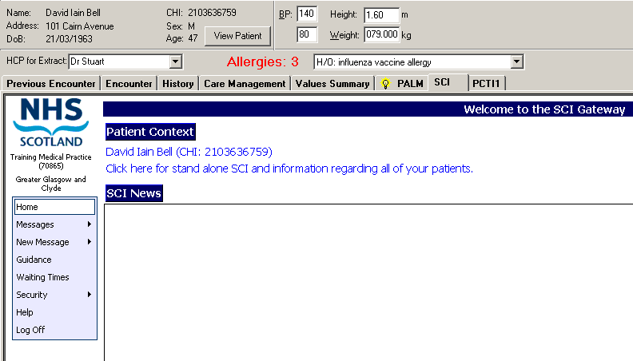
Click here to open information for all patients

There are a variety of other ways which you can access SCI Gateway depending on the primary care system your practice uses – refer to your system’s supplier for more information on accessing SCI Gateway through your primary care system.

Hospital/Clinic Specific
To access from the Windows desktop, double click on the SCI Gateway icon. The SCI Gateway icon on your desktop may look different to the one pictured above, depending on which version of Windows you are using.

Some hospitals will use their patient management system to access messages from SCI Gateway. Contact your system administrator for information on receiving messages through your outpatient management system.

Patient Specific
By accessing SCI Gateway from within a patient record from the hospital/clinic patient management system, you can view any messages for the selected patient as well as create a new referral, an advice request, a supplementary message or a clinical dialogue message and pre-populate the message with the patient’s relevant clinical and demographic details.

Passwords & Security
When you log onto SCI Gateway you are establishing a connection over the NHSNet, therefore you will need a SCI Gateway user name and password for security purposes. In the first instance you will be given these by your system administrator – you will be able to change your password at any time after this.

Note: Some primary care systems automatically log you onto SCI Gateway when you log onto the system.

Logging on to SCI Gateway for the first time
When you log on to SCI Gateway for the first time you will be asked to change your password for security purposes and you may be required to add your demographic information:

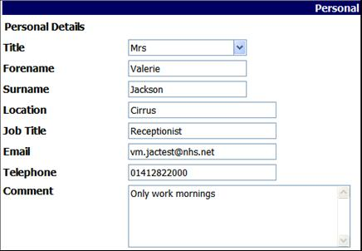
Select Title from drop down list
Enter your own details into fields
Enter any comments that are relevant

- Surname and Forename are mandatory fields. However, the more information that is recorded the easier it will be for your system administrator to manage your account.
When you add your email address it must be in a valid email format or the following message will be displayed
You can save the information after you have completed the security questions – see next page.
When you have saved your details a message will be displayed – see next page.

Security Questions
Pictured below is the Security Questions window which is displayed when you log on to SCI Gateway for the first time. You are required to select three security questions and your answers from the lists provided.

The answers you provide will be stored and used as security change questions which will allow you to reset your password if you should forget it in future. It will no longer be necessary for you to contact your local administrator to reset your password.

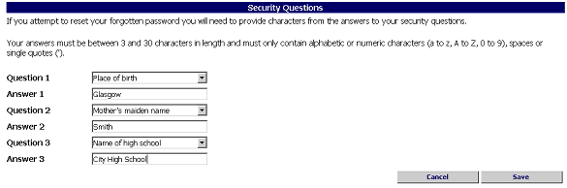
Enter answers in the fields below your selected questions
Select question from the drop down lists
Click on Cancel to go to the Home page – see next page
Click on Save to save your answers

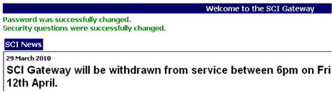
Message confirming your personal details and security questions have been saved

Your security questions and answers and demographics, if applicable, have now been saved to your login account.

- You can create your own security questions by typing your preferred question in the relevant fields.

Security Question Options:
There are 10 security question options. You must select an option that is relevant to you from the list for each of the three questions. The options are:
- Colour of eyes
- Father’s given name
- Favourite colour
- Favourite country
- First pet’s name
- Mother’s maiden name
- Name of first school
- Name of high school
- Place of birth
- Town/suburb of birth

Security Questions Answer Rules
- Answers must be between 3 and 30 characters
- Must contain only alphabetic or numeric characters, spaces or single quotes

You can bypass the security questions if you select Cancel as described on the previous page and you will be returned to the Home page. Each time you log onto SCI Gateway the Security Questions window will be displayed until you add them to your account.

Note: If you do not add security questions and answers, the following message box will be displayed and in the event that you forget your password you will not be able to reset it yourself.

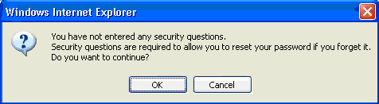

You can change your security answers and / or questions by pointing to Security and selecting Change Questions from the Menu Bar as pictured below:

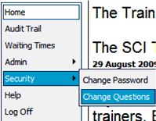
Point to Security and select Change Questions

User Reset Password
If after a period of inactivity on SCI Gateway or a user forgot their password, previously they would have had to call their local administrator to have it reset. Users can reset their own password at the login page if they have set their own security questions.

Access SCI Gateway in your usual way either from the desktop icon or through your other IT system until you have the login window displayed:

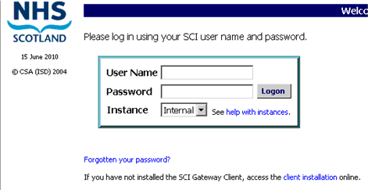
Click on the link
‘Forgotten your password?’

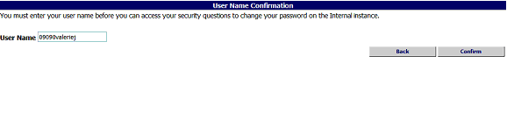
Enter user name here
Click here to Confirm

Pictured below is the Security Questions Confirmation window which is displayed after clicking on confirm as described on the previous page.

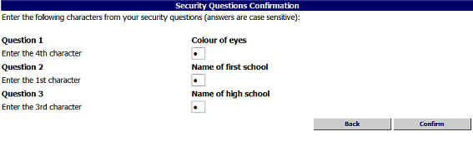

Enter the characters from your security answers into the relevant fields
Click on Confirm

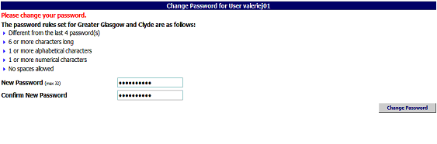

Enter a password in the New Password and the Confirm New Password fields
Click on Change Password

After clicking on Change Password you will be taken to the SCI Gateway Home page and a message will be displayed confirming you have changed your password.

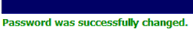

You can change you password at any time when you are logged in to SCI Gateway by pointing to Security and selecting Change Password from the Menu Bar as pictured below:

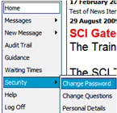
Point to Security and select Change Password

The SCI Gateway Homepage
The SCI Gateway Homepage is displayed when you log on to SCI Gateway. Some of the items in the navigation bar and links pictured may not be available depending on how SCI Gateway is configured in your local health board area.

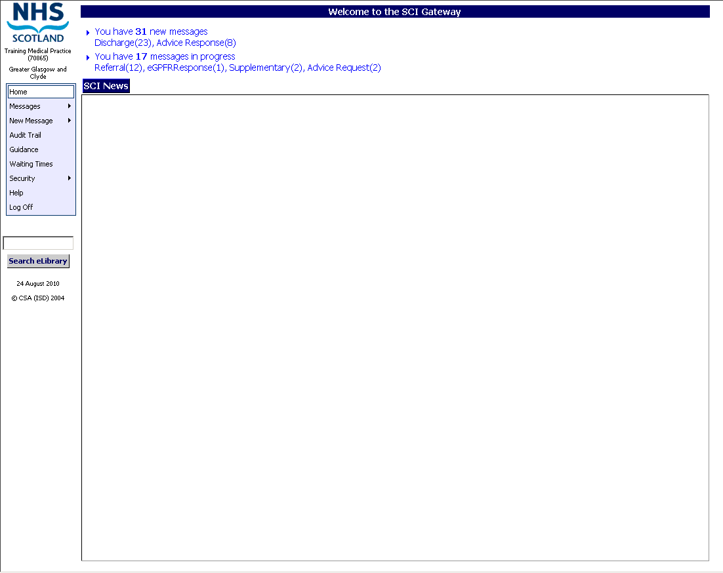
Navigation Bar – see below
Check here regularly for important information regarding SCI Gateway
Check here regularly for important information from your local health board

Navigation Bar Options
 | Return to the SCI Gateway homepage
 | Allows users to access the messages worklists – see page 5–2
 | Allows users to make new messages – currently referrals and advice requests - see page 3–2
 | Allows users to access the audit trail – see page 6–2
 | Allows users to access local and national referral guidelines
 | Allows users to access the NHS Scotland Waiting Times web page
 | Allows users to access SCI Store web pages
 | Allows users to change their password or security questions– see page 2-8
 | Allows users to access SCI Gateway online help pages – see page 6–9
 | Logs off SCI Gateway and closes Internet Explorer window
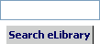 | Allows users to access national e-library website for NHS health information

Navigation Links
Navigation links allow you to open the message worklist to display only those messages specified in each link. In the example pictured on the previous page there are ‘17 messages in progress’ and ‘21 new messages received’.

Using the links you can choose to display all 21 new messages in the worklist or you can choose the link to open the worklist for one message type. For example, if you click on the ‘Advice response(2)’ link it will open only the Advice response worklist.

Opens all new message worklists – Referrals, Discharges, Advice Requests, Advice responses, eGPFR Requests and eGPFR Responses - you will only see those for which you are configured

Opens the discharge worklist

Opens the eGPFR request worklist

Opens the supplementary worklist

Opens the advice response worklist

Opens the referral worklist - filtered to show only referrals not yet sent but already have an appointment booked at the receiving hospital, usually urgent referrals

Opens the all message worklist - filtered to show messages not yet sent

Opens the referral worklist - filtered to show only referrals not yet sent

Opens the eGPFR response worklist – filtered to show only eGPFR responses not yet sen

Opens the advice request worklist – filtered to show only advice requests not yet sent

Passwords In SCI Gateway

Changing Passwords
You can change your password at any time by following the steps outlined below.

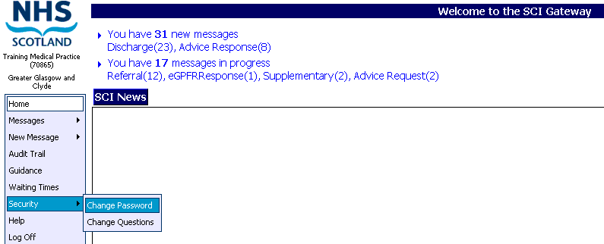
Point to Security and click on Change Password

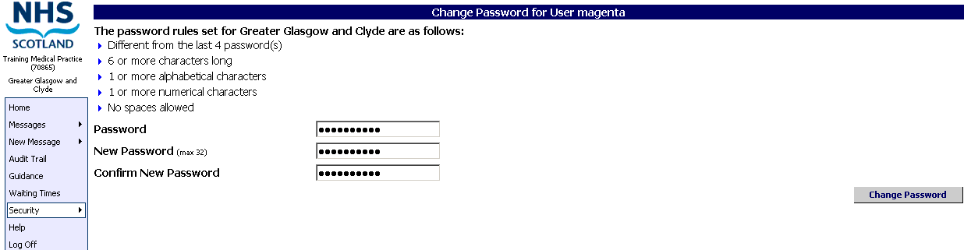
Enter your current password and enter and confirm your new password
Click on Change Password

Password Security
- Your password must be at least six characters in length
- Your password must have a combination of alpha and numeric characters and is case sensitive
- Never write down your password or reveal it to others
- When keying in your password it will be displayed as a series of  so that it cannot be read
- When you change your password, the new one must not match any of the previous four passwords used for your user name
- If you think someone else may know your password, you should change it as soon as possible

Password Expiry
Passwords in SCI Gateway are configured to expire after 90 days. Messages indicating the countdown to the expiry date will be displayed when you log on from seven days prior to that date. You should change your password during this notification period.

Password Grace Period
If you do not change your password prior to it expiring, the system will initiate a 21-day grace period. If you log on during this time you will be prompted to change your password before you can proceed.

If you do not change your password prior to it expiring or during the 21-day grace period, a message will be displayed the next time you log on informing you that your password has expired. If this happens you must contact your system administrator to have a new password issued.

Generating & Sending Messages
SCI Gateway uses protocols to generate a variety of messages, for example, referrals, advice requests and clinical dialogues. Protocols are created and maintained at local health board area level.

If you access SCI Gateway through a third party IT system e.g. a GP primary care system or a hospital patient management system the protocol will be pre-populated with much of the information necessary to produce the message / letter, such as clinical and medication information and patient demographics.

Before using SCI Gateway to generate and send messages, practices and healthcare providers may wish to consider how they can adapt their business processes to use the system to its best advantage. For example, you may decide that admin staff can use SCI Gateway to complete a protocol, but that only clinical staff can send it, once they have checked it is OK. Alternatively, admin staff could complete the protocol and print a preview of the letter for clinical staff to authorise prior to admin staff sending it.

At this time the most common messages sent through SCI Gateway are referrals; therefore this guide will use referrals to illustrate the generating and sending of messages.

This section covers:
- Creating a New Message
- Completing a Protocol
- Spell Checker
- Previewing & Printing the Letter
- Parking a Message
- Adding Attachments to a Message
- Removing Attachments from a Message
- Sending the Message
- Further Options When Sending a Referral
- Booking Appointments On-Line
- Creating Supplementary Messages

Creating A New Message
The method for creating new messages is the same for referrals, advice requests and clinical dialogues. In the following pages the example used will be for a referral, however, unless otherwise stated all actions and options will be the same if you were creating an advice response, a back to referrer or a clinical dialogue. From the SCI Gateway home page:

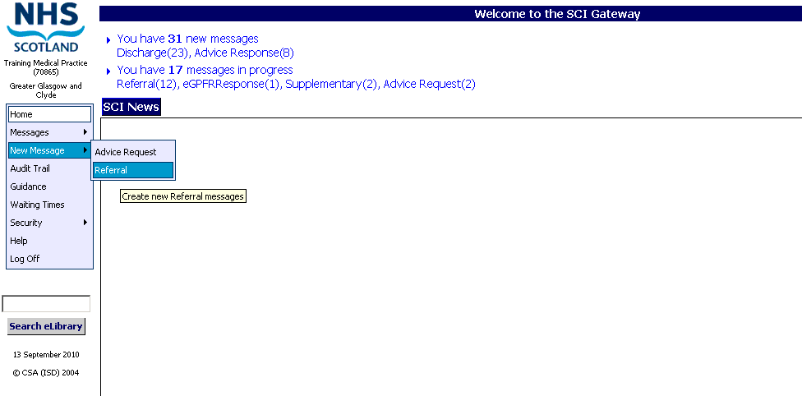
Point to New Message and click on Referral

Select these options from My Favourites – see page 3-5 for information on My Favourites
Alternatively select the destination of the referral from the drop down lists

Click on the Create button – Go to page 3-13
Allow a few moments after selecting from the drop down lists for the screen to refresh.

The default Health Board Area is determined by the location of the sender through SCI Gateway configuration, although it is possible to select a different area if required.

After choosing a destination and destination type (hospital / clinic / allied health professional or GP practice) you can choose from the list of specialties available within that location. Below that there may then be an option for choosing a clinician. This is a locally configurable option and may not be available in your health board. Finally, you can choose the protocol – a specialty may have one or more protocols associated with it.

If there are additional services/branches to Non – GP Locations/Providers there maybe a number of other destination options. The order of the drop down destination options for these services is configured by your local health board and may be different for each service. However, the protocol will always be the last option.

In order to meet the requirements RTT targets hospital and health board preference is for GPs to refer to a specialty rather than a named consultant. Therefore, there may be occasions when the Consultant option is not available in the New Referral Destination options.

Destination drop down lists will be filtered to only display those destinations that have a protocol attached.

After clicking on the Create button as described on the previous page the protocol will be opened. For information on completing a protocol go to page 3-13.
My Favourites
Users can create a list of shortcuts to destinations and services they use most frequently.

This facility is particularly useful for practices that regularly send messages to services out with their own Health Board area.

When selecting the destination options for your messages you will find the Add Favourite button. This button allows you to add the destination and service type for your message to your list of favourites.

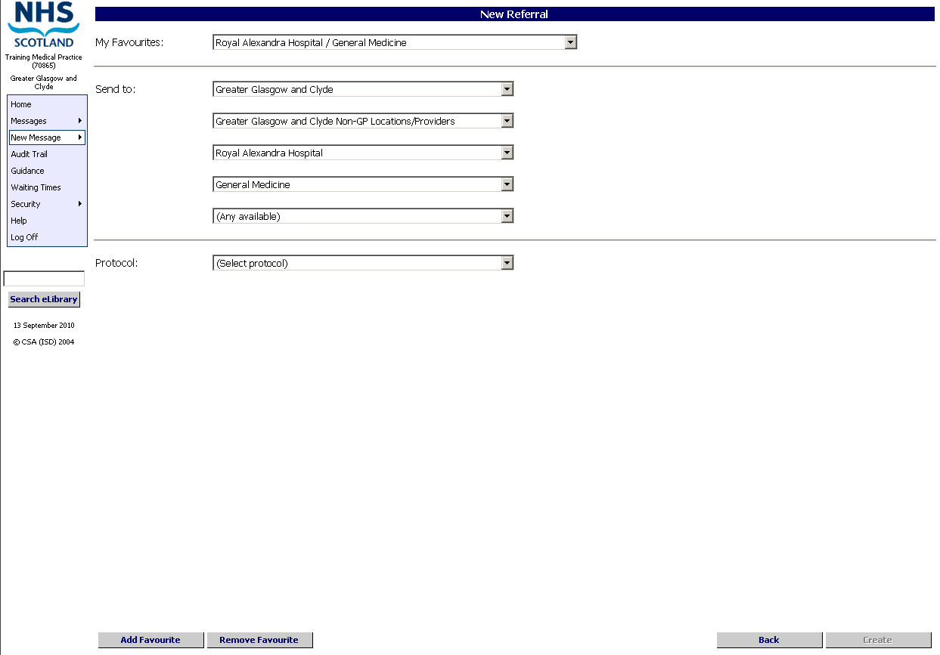
After selecting your Health Board Area, Destination Type and Destination, select any other required options and click on Add Favourite

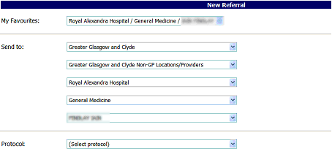

You will now be able to select the destination and service from the My Favourites drop down list anytime you create a message – this will pre-populate the relevant fields.

My Favourites Options
Destination – You can create a favourite where the link populates the destination field for the hospital / clinic only. For example, Royal Alexandra Hospital.

Specialty / service – you can create a favourite where the link populates the specialty field with a specific specialty at the hospital destination. For example, General Surgery at Royal Alexandria Hospital.

Healthcare Professional / Other – You can create a favourite where the link populates the consultant field with a specific consultant and protocol, for the specialty at the hospital. For example, Consultant’s name, General Surgery at Royal Alexandria Hospital.

Protocol – You can create a favourite where the link populates the protocol field with a specific protocol for a specialty at the hospital. For example, AC Upper GI, General Surgery at Royal Alexandria Hospital.

The list in My Favourites is unique to your login.

CHI Demographic Matching
Users who do not have a stored record of patients’ CHI numbers or have access to CHI through the usual format have the functionality to look up a patient’s details and obtain a match for their CHI while in the process of making a referral or an advice request. After clicking on Create as described on page 3–2 the following search criteria window will be displayed:

Enter patient demographic details in the required fields

Click here to find a Match
Click Cancel to continue to the protocol without patient demographics

If the information entered in the Patient Matching window as described above finds a match the protocol will open with the first tab displayed as pictured below. Click on the Demographics tab to display the patient details:

Click on Demographics to view patient’s details

Note: All fields in the Patient Matching window are mandatory.
Pictured below is the protocol window with the Demographics tab displayed after clicking on the tab as described on the previous page.

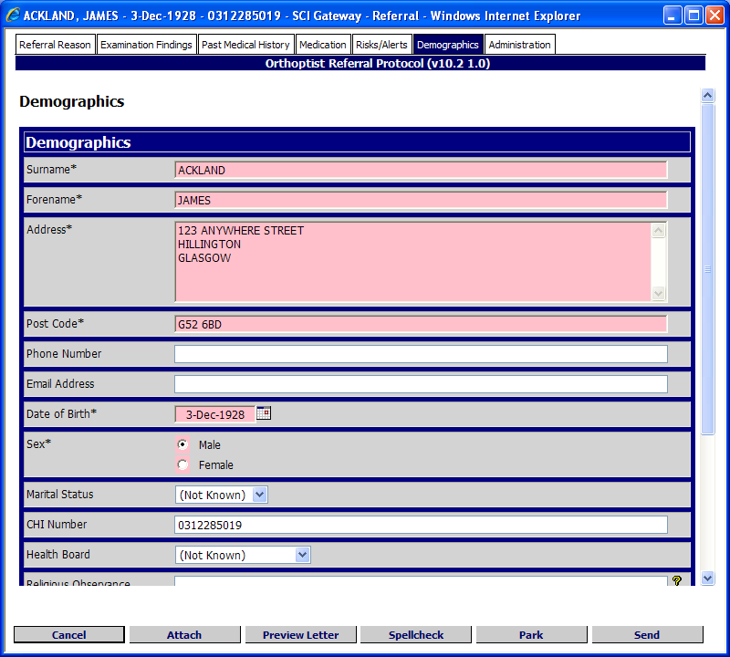
Patient demographics including CHI populated

Complete mandatory fields and add any other information required and either Park or Send the message as required. See pages 3 – 8 to 3 – 32 for more information on completing a protocol and parking or sending.

CHI Demographic Match with RTT
If you get a match as described on the page 3–6 and you are configured for CHI Match with RTT, the following window will be displayed with the patient’s unique care pathway number displayed as a hyperlink:

Click here to generate a new unique care pathway number. See next page
Pathway ID is the patient’s unique care pathway number. Click on it to proceed
Click here to proceed with patient demographics but without a pathway ID. See next page

Click on Patient demographics tab to display the CHI and patients demographics

Click on Administration tab to display the unique care pathway number
Pictured below is the protocol opened after clicking on the ‘Pathway ID’ as described on the previous page and with the RTT tab selected:
Click on RTT tab to view, add or amend the RTT information
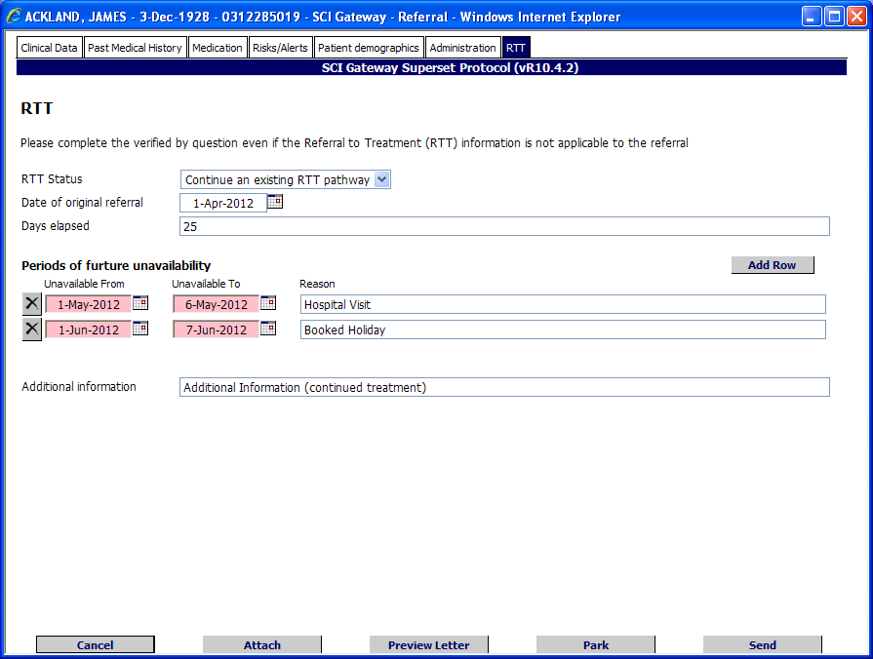
Click on Park or Send as required

Pathway ID
If you select the Pathway ID as described on the previous page, the protocol will open with the patient’s demographics, CHI, unique care pathway number and RTT details populated. The RTT details can be amended if necessary. A patient may have more than one Pathway ID displayed if they have more than one referral in the RTT pathways.

New Pathway
If you select the New Pathway button as described on the previous page the protocol will open with the patient’s demographics, CHI and unique care pathway number details populated. The RTT tab will have to be completed with your new information.

Not on a Pathway
If you click on Not on a Pathway button as described on the previous page, the protocol will open with the patient’s demographics, CHI details populated. Complete the protocol as necessary.

Cancel
If you select Cancel as described on the page 3–6 the protocol will open and no patient details will be populated. Cancel option is not available once you have found a match when you are configured for CHI with RTT.
CHI Look Up through SCI Store
If you are configured to use the CHI Look up through SCI Store service, when you click on Create after selecting your message destination options as shown on page 3–2, the following window is displayed:

Enter patient demographic details in the required fields
Click on Lookup

The results of your search criteria will be displayed as in the window pictured below:

Click on the patient’s name to select and continue to the protocol

The protocol is opened, click on the Patient’s Demographics tab to view the information
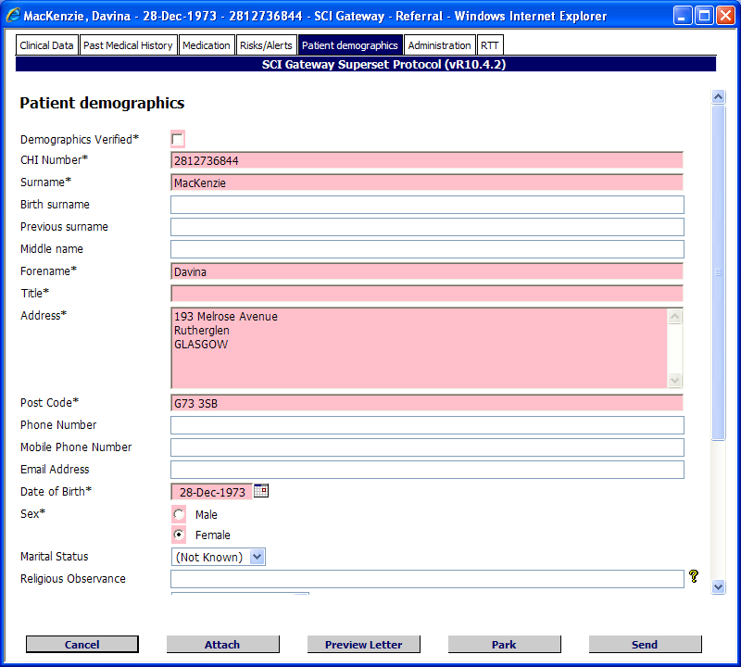
The patient’s demographics displayed here

NO Match
If the information entered in the Patient Matching or Patient Lookup window does not find a patient matching your search criteria the following message will be displayed:

If the message above is displayed click on Cancel to proceed without a CHI. The protocol will open without populating any patient demographics. Alternatively, you can amend the details entered and search again.

When searching for a patient’s CHI a message will be displayed showing which system is being searched as in the examples pictured below:

If you are configured for SCI Store Lookup and RTT the pathways for the selected patient will be looked up and displayed as shown in the RTT Lookup section pictured on page 3–8.

The CHI Demographic Look up with RTT option is only available for Tertiary referrals.
If a patient does not have a CHI number i.e. a new patient at a GP Practice, you should go through the usual channels to obtain a CHI. This functionality is initially for use by Opticians who do not have access to CHI.
If you have any issues accessing a patient’s CHI you should speak to your system administrator in the first instance.

Completing A Protocol

The Protocol Window
When you click on the Create button as described on page 3–3, a protocol window similar to the one pictured below will open, allowing you to enter and review information you wish to appear on the message.
Active tab is highlighted

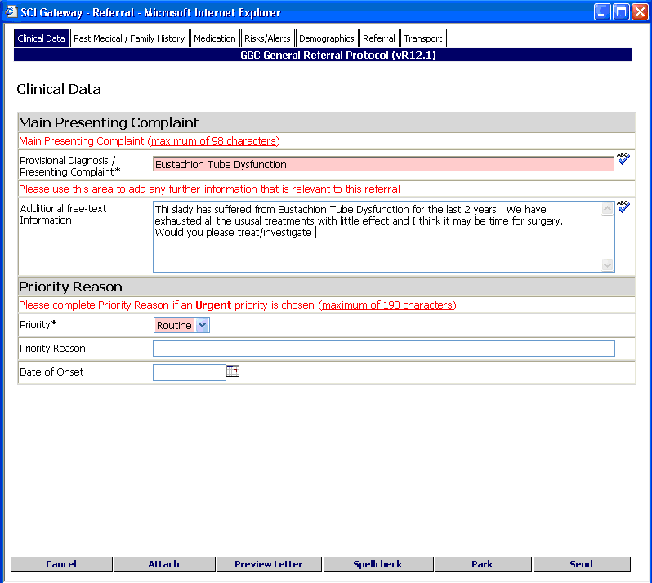
Click here to cancel and return to the Worklist
Click here to add an attachment to the message – see page 3-24
Click here to spell check letter – see page 3-18
Set priority here

Click here to preview the letter – see page 3-22
Click here to save data entered for completion later – see page 3-23
Click here to send the message when complete – see page 3-29

Note: All protocols within the application work in a similar way. The protocol window consists of a series of tabs that allow you to enter information you want to include in the referral letter.

Fields marked with an asterisk and coloured pink are mandatory and must be completed.

The Attach button may not be available, depending on how SCI Gateway has been configured in your health board area.

Commonly Used Tabs
Although protocols can differ greatly in layout and what information is required, there are certain commonly used tabs which will appear in most protocols. The protocol in the example has a ‘Referral’ tab which is more commonly known as ‘Administration’ and a ‘Transport’ tab.

If you have accessed SCI Gateway from a patient encounter in your primary care system, or another many of the fields will be pre-populated with data from the patient’s record. Data used to pre-populate the fields is dependent on the protocol used.

Tab Content | Function
Clinical data | Records the diagnosis / presenting complaint, and any related information
Advice | Record details of the advice requested
Past Medical / Family History | Records any relevant past medical history – you can delete any history pre-populated from your primary care system that is not relevant
Medication | Records the patient’s current and recently administered medication – you can delete any medication pre-populated from your primary care system that is not relevant
Risks / Alerts | Records details of risks and alerts for the patient, such as allergies, intolerances, tobacco and alcohol consumption, etc
Patient Demographics | Records details of patient’s name, address, CHI number, etc.
Administration / Referral | Records details of the sending location and the referring / requesting clinician
Transport | Records details of the patient’s transport requirement to their first appointment only in relation to a referral
Referral to Treatment (RTT) | SCI Gateway allows for some new or changed referral protocol questions to help with Referral to Treatment targets and to improve data quality.

Key Messages
Some protocols may include tabs containing key messages, which can be a mixture of local and national guidelines to assist in the completion of the referral.

Help Links
Help links – indicated by a Help icon – are included for certain fields to assist in the completion of the referral. Clicking on the icon opens a message box containing information relevant to the field.

Interactive questions
Some protocols may have interactive questions i.e. fields or options that when selected will display new fields or additional questions that the user is required to answer. Pictured below are examples of interactive questions in a referral protocol. In this example a referral protocol has been opened after selecting the message destination options and clicking on Create in the New Referral window:

Priority Question
Interactive question
Select Routine and the Priority Reason is not a mandatory field and is greyed out and unavailable

Interactive question
Select Urgent and the Priority Reason becomes a mandatory field and must be completed
Interactive question
Date of birth – if the patient is older than 10 years of age the next field is greyed out and inactive
Interactive question
Date of birth if the patient is less than 10 years of age the next field is mandatory and Parent’s Guardian must be completed

Date of Birth Question

Types of interactive question
The following tables give examples of different types of interactive questions and the different ways which they may be displayed:

Question | Action
Does the patient have mental health issues? | If you select the “Yes” option a further field may be activated or displayed asking for more details
Has the patient had X-rays taken? | If you select the “Yes” option a further field may be displayed asking for more details e.g. asking where they were taken, if they have been sent by post or where they are stored
Is the patient under 17 years of age? | If you select the “Yes” option a further field may be displayed asking details of the responsible parent/guardian

Question | Style | Action
Questions may take the form of pre-populated information as in a date of birth field |  | The question is already answered and the user needs to complete the following questions / fields
Questions may take the form of a radio button |  | The user will make a selection and new questions / fields may be activated or displayed
Questions may take the form of drop down lists |  | The user will make a selection and new questions / fields may be activated or displayed

The above are just a few examples of the interactive questions available. There may be many more depending on the options used by your local health board protocol authors

Add / Delete Rows
You can add a row in certain parts of the protocol by clicking on the button. You can delete rows in certain parts of the protocol by clicking on the delete button – this can be used to ensure irrelevant data is not included in the referral letter.

Users can re–instate rows that have accidentally been deleted. When a user clicks on the delete button the row is marked as deleted rather than removed.

Delete button changes to undo button and data is still visible but crossed out

Click on the Undo Row Deletion button to return the field to its undeleted state.

When the Hide Deleted Rows button is clicked, the deleted rows in the table will be hidden from view and the button text will be changed to Show Deleted Rows.

When the Show Deleted Rows button is clicked, the hidden deleted rows will be redisplayed and the button text will be changed back to Hide Deleted Rows.

Click here to hide the deleted row(s)
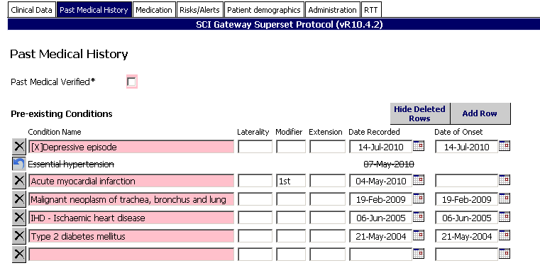
Click here to add a new row

Previewing a letter with deleted rows
When the Preview Letter button is clicked, all table rows marked as deleted will be ignored and will not appear on the displayed letter thus allowing the user to view the letter as it will finally be generated with the deleted rows removed.

Table rows marked as deleted

Click on Preview letter button

Section of letter on pre-existing conditions showing deleted items have been ignored

Parking/Sending a referral with deleted rows
If the user clicks the Park or Send button, any table rows marked as deleted, including any hidden deleted rows will be permanently removed from the referral before it is parked. These rows cannot subsequently be re-instated when the referral is re-accessed.

Table rows marked as deleted
Click on Park or Send the changes will be saved

The removed rows are not displayed on re- opening the parked referral

Priority of Referrals
A referral requires a priority to be set depending on how soon the referrer deems it necessary for the patient to be seen. Generally the default setting is ‘Routine’ and the sender has to actively select an alternative status when required in the protocol as shown below:

Statuses for Referrals are:

Status | Worklist Icon/Flag
Routine | No Icon
Soon – only available in selected health boards
Urgent
Urgent –Suspected Cancer
Advice

If you do not have any of your required priorities in your protocols contact your local system administrator More information on the urgent suspicion of cancer referral category and cancer waiting times data and definitions can be found at http://www.isdscotland.org/Health-Topics/Waiting-Times/Publications/

Spell Checker
Prior to sending, messages can be spell checked for accuracy.

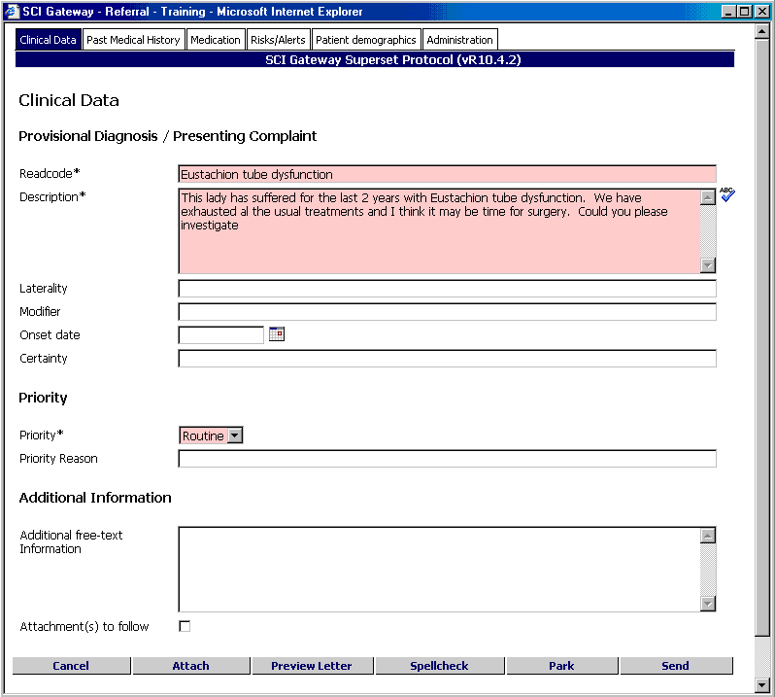
Click on the ABC icon to spell check the field. Alternatively click here to spell check all fields in the protocol that have been configured for spell checking

The spell checker is displayed with the first incorrect item highlighted.

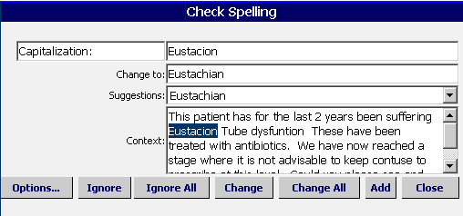
Click on the drop down list to view other suggestions
Click on Add if you want to save the highlighted word to the user dictionary
Click on Change to accept the change offered

The spell checker will continue to go through the document highlighting each error until it is complete and the following message is displayed.

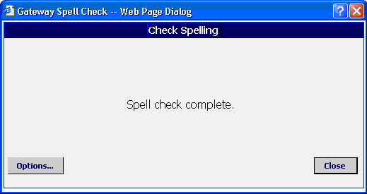
Click here to Close

If you have added a new word to the user dictionary as shown on the previous page the following message will be displayed.

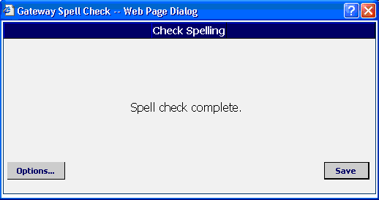

Click here to view Options (see next page)
Click here to Save new words and close the Spell Check

If you click on the Close icon to close the Spell Check after adding a word to the user dictionary the following message box will be displayed:

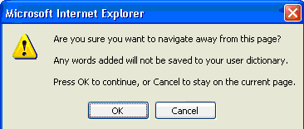
Click on Cancel to return to the previous window and save the changes

Note: If you select OK any words you have added to the user dictionary will be lost.
Words added to the user dictionary when using the Spell Check on SCI Gateway will be remembered and will not be displayed in future as an incorrect spelling.

Spell Checker Options

Suggestions
When you click on the drop down list there will be other suggestions available. The suggestion displayed is offered as the most likely solution to an incorrect spelling. You may select any other suggestion offered in the list.

Options
When you select this option the spell checker offers a number of word formats that you might want the checker to ignore, for example, words that are all capitals or words which contain numbers such as post codes.

Ignore
When you select this option the spell checker will ignore this instance of the word in this message.

Ignore All
When you select this option the spell checker will ignore all instances of the word in this message.

Change
When you select this option the spell checker will change the word highlighted to the suggestion it has offered.

Change All
When you select this option the spell checker will change all instances of the word highlighted to the suggestion it has offered.

Add
When you select this option the spell checker will add the word highlighted to its dictionary so that it recognises it at any time in future messages.

Close
When you select this option it closes the spell checker.

Note: The Spell checker will only check the parts of messages that are detailed by the protocol and marked with the icon. If you are unsure what is checked please contact your system administrator.

Some protocols may not have the spell check option available.

Data validation
When creating messages in SCI Gateway using pre–population from third party systems, for example, GP IT systems EMIS and INPS, patient data goes through a validation process to ensure that the data meets the necessary Standards. If there are errors in the patients data users will receive error messages explaining the error(s) and allow you to take action to resolve the issue and continue with sending the message.

After clicking on Create , as described on page 3–2 your third party system will attempt to retrieve patient information. Pictured below is an example of an error message displayed when the retrieval failed because the patient’s post code is incorrect:
Click here to save the error message
Click here to return to protocol – no information will be pre-populated
Click here to continue - patient demographics and medical data will be pre-populated excluding the error item

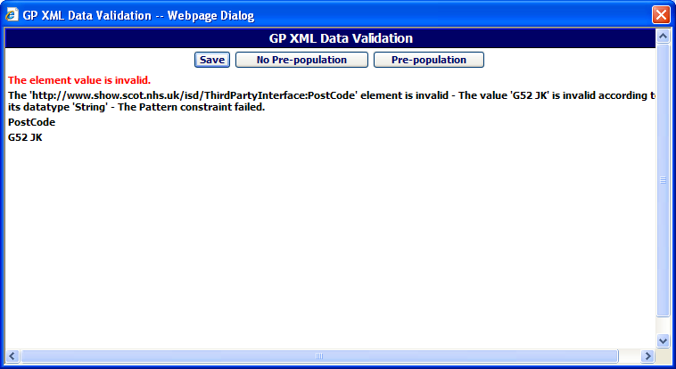
Validation message displayed with details of errors

- Save – If you select this option the windows save file window will be displayed and you can name and save the message.
- No Pre-population – If you select this option you will be returned to the protocol and none of the patient’s demographics or medical information will be populated. You have the option to manually enter the information or return to the third party system and amend the patient’s details there.

- Pre-population – If you select this option you will be returned to the protocol and all of the patient’s demographics and medical information will be pre-populated except the information that was indicated as missing / incorrect in the validation message.

Previewing & Printing The Letter
You can generate a preview of the letter, and print it if required, prior to completing the protocol and sending the message. For example, you may wish to print a copy of the letter for the doctor to approve before sending.

1 | In the Protocol window, click on the Preview Letter button  Note: If the referral has been previously parked (see following page) you will have to open it by clicking on the patient name in the Referral Worklist | 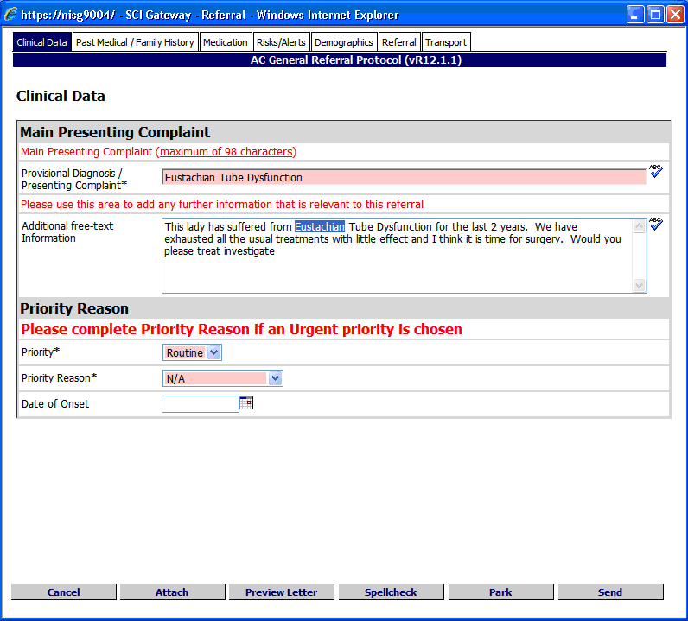
2 | The letter is displayed in a separate window – click on the Print button to produce a printout | 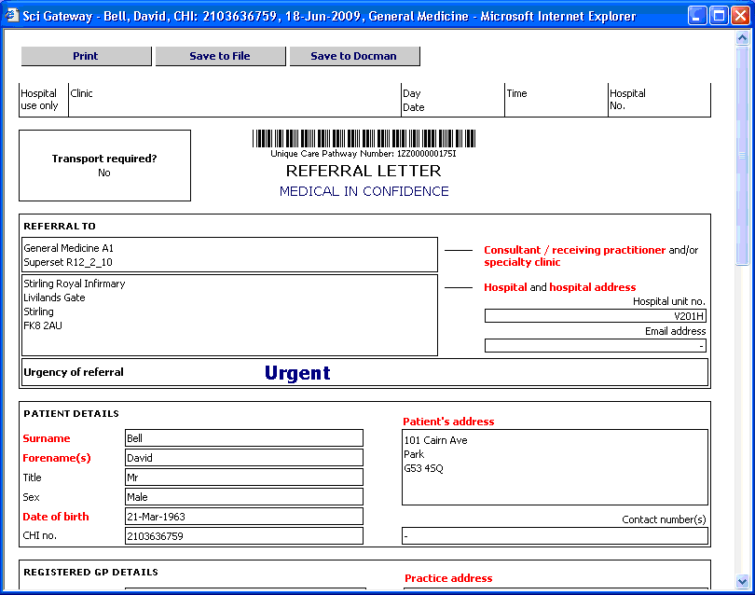
3 | Close the Preview Letter window by clicking on the Close icon – you will return to the Protocol window | 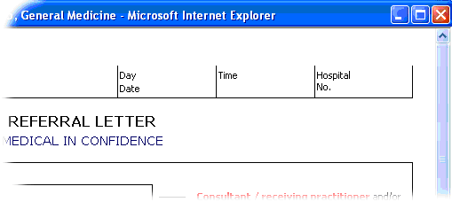

Parking A Message
Parking a message allows you to save the information entered in the protocol; the message is not sent to the hospital at this stage.

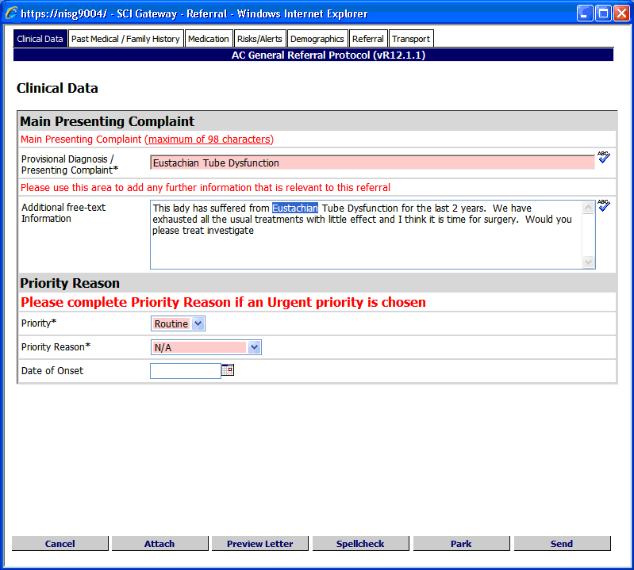
Click here to Park the referral protocol
Newly parked message appears at the top of the Worklist – see Section 4 for more information about managing the Referral / Message Worklist

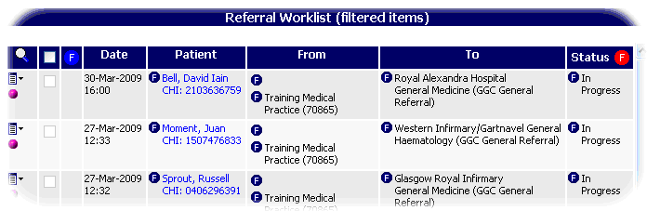

Note: When you park a message for the first time it is given the default status for messages that have not yet been sent – usually ‘In Progress’, although this is dependent on how SCI Gateway has been configured in your health board area. See Section 4 for more information on changing the status of a message.

The Referral Worklist pictured above is for the whole practice and therefore shows referrals for several patients.

Adding An Attachment To A Message
You can attach a file to a message, such as a Word document or a picture, by following the steps outlined below:

1 | With the Protocol window open, click on the Attach button | 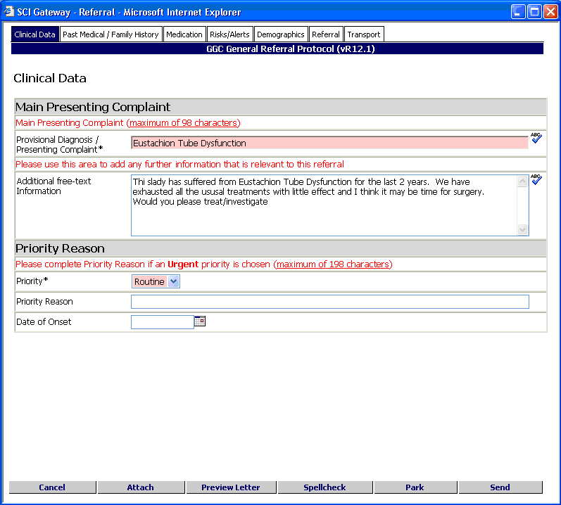
2 | In the Message Attachments window click on Attach Files… to add a file from your local area network or PC | 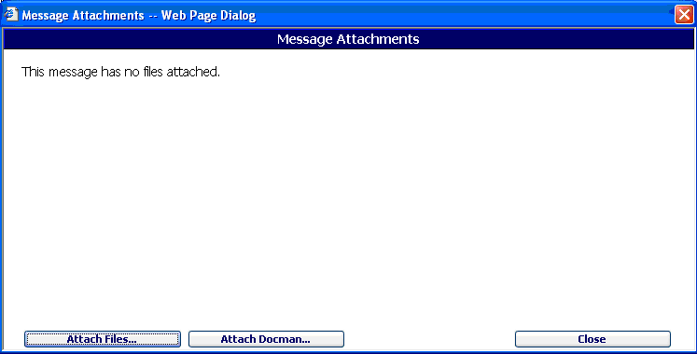
3 | In the Choose File window, navigate to the location of the file you wish to attach and click on the file to highlight then click on Open | 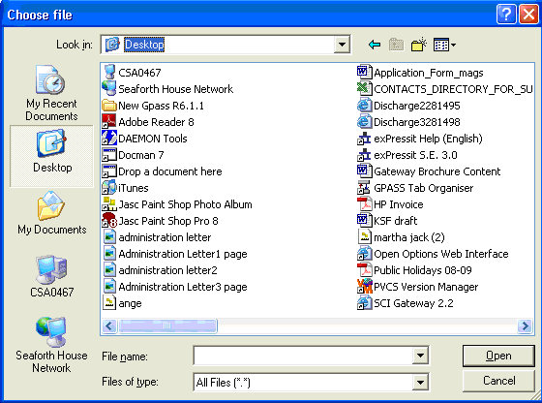
4 | Click on OK to accept the next two confirmation messages  Click on Ok to acknowledge the messages | 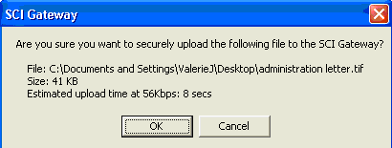  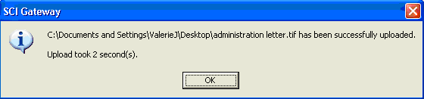
5 | The attachment is displayed with an icon depicting the type of file attachment e.g. Word document  Click on Close | 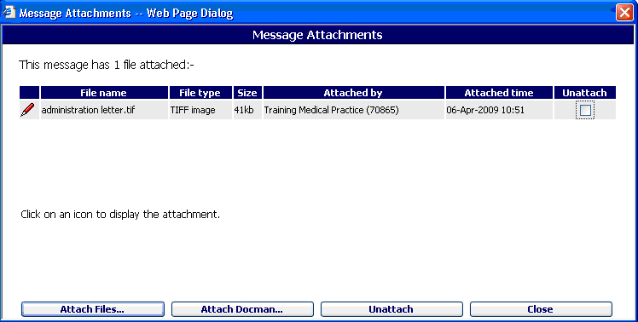

Note: Messages with an attachment are shown in the message Worklist by the paperclip icon.

There is an alternative way of attaching files from the Message Worklist see page 5–17 for more information.

Adding An Attachment To A Message From Docman
You can attach a file to a message from Docman, such as a Lab result or a picture, by following the steps outlined below.

1 | With the Protocol window open, click on the Attach button | 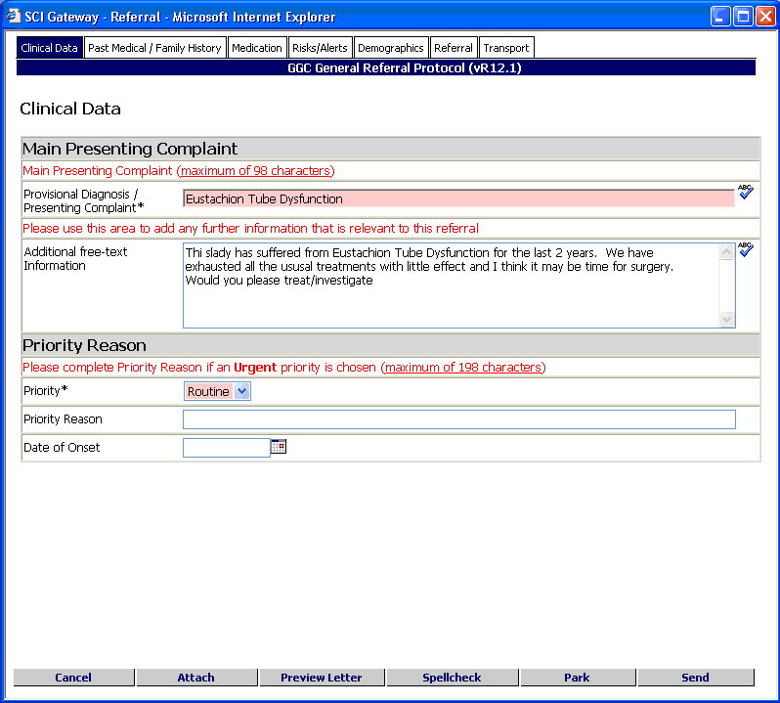
2 | Click on Attach Docman to add a file from your local Docman system | 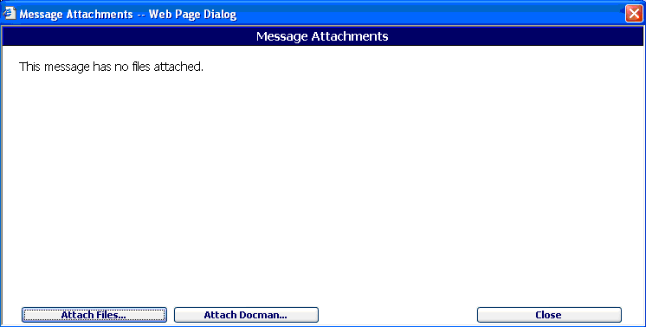
3 | In the Document Viewer window, place a tick in the box next to the file you wish to attach and click on Confirm Selected Documents.  Note: If you do not have a preview of your documents as in the picture displayed see your system administrator | 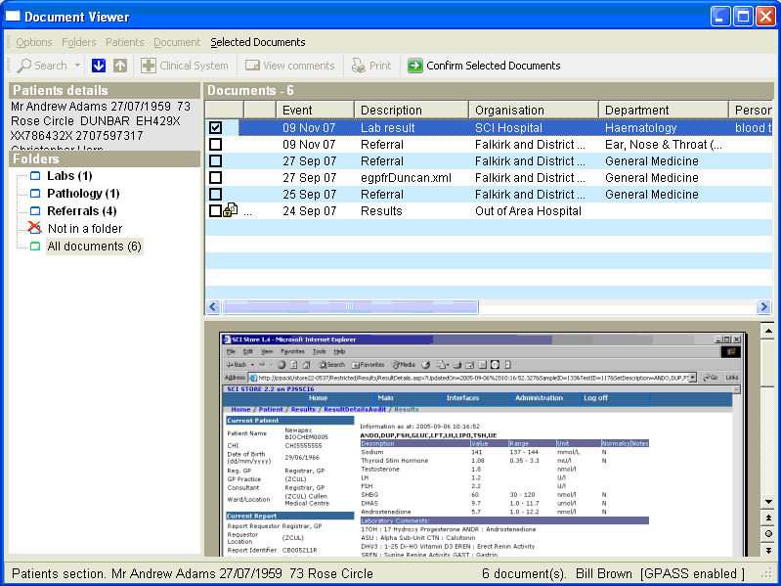

Note: You can attach more than one document at a time by placing a tick beside all the required documents.

4 | Two confirmation messages will be displayed in succession click on OK to confirm.  Click on Ok to confirm | 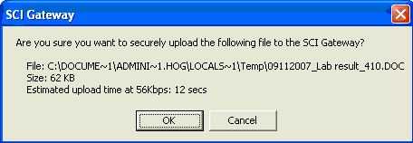  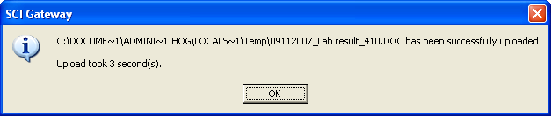
5 | You are returned to the Message Attachments window, click on Close to return to the protocol or worklist  Click on Close | 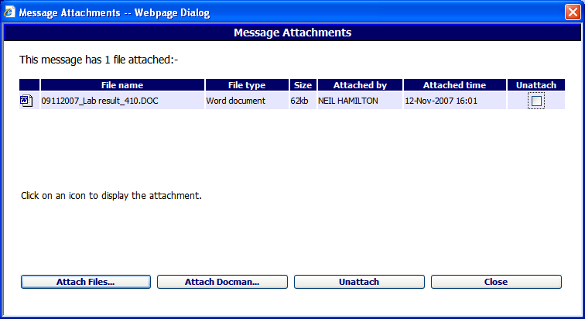

Your files will be attached to the message and will be displayed in the worklist with a Paperclip icon when you Park or Send the message, as shown in the example below.

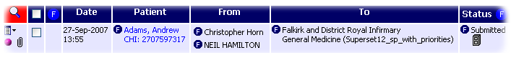

Note: This facility to attach from Docman requires activation at your location level on SCI Gateway. Contact your system administrator in the first instance if you are not able to attach files from or save to Docman.

Removing Attachments From A Message
You can unattach a file that you have attached to a message in error. Follow these steps:

1 | Click on the Paperclip to open the Message Attachments window for the message required  Click here to open | 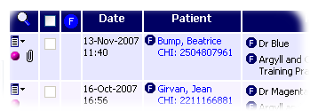
2 | The Message Attachments window is displayed. Place a tick in the box in the Unattach column and click on Unattach  Place a tick here  Click on Unattach | 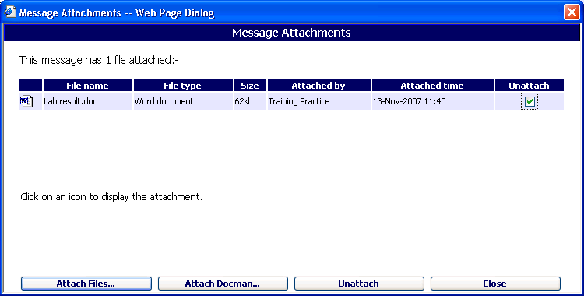
3 | Click on OK to confirm  Click on OK | 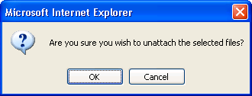
4 | The Message Attachments window confirms that the message no longer has an attachment. Click on Close to return to the worklist.  Click on Close | 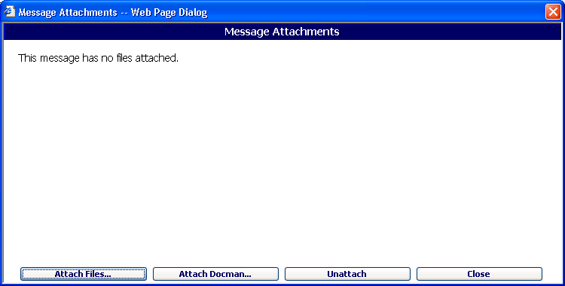

Sending The Message
When a protocol has been completed and the message is ready to be sent, search for the relevant entry in the Worklist, in this instance the Referral Worklist and follow the steps outlined below. See Section 5 for more information about searching the Message Worklist.

1 | From the Worklist, click on the patient name for the message you wish to send  Click here | 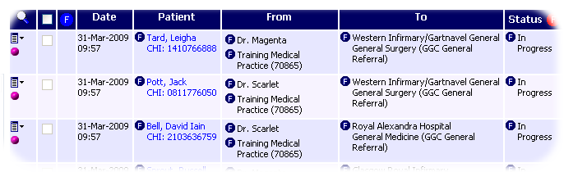
2 | In the Protocol window, ensure all required data has been entered and click on the Send button | 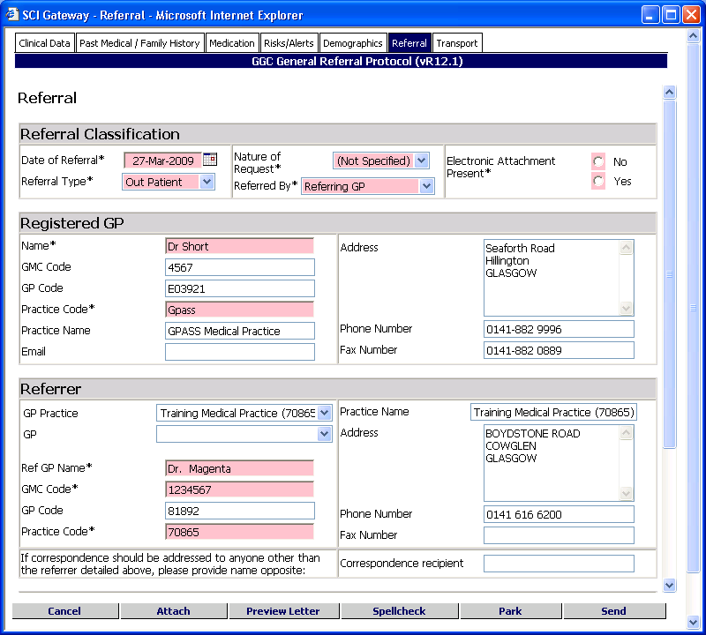
3 | The Referral Options window will be displayed with the header indicating that the message will be accepted    Click on the Proceed button to continue | 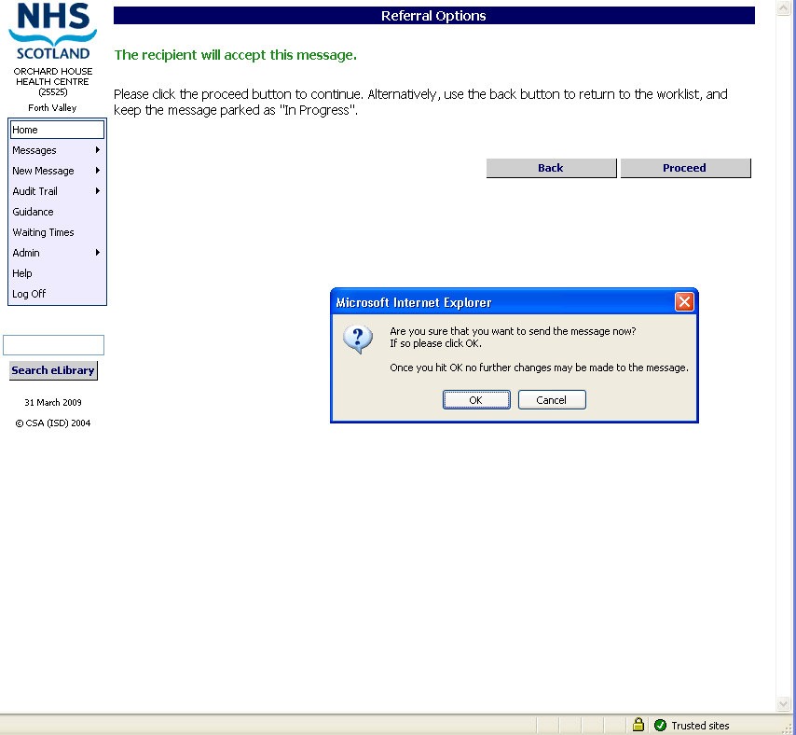
4 | A final message box will be displayed. Click on Ok to confirm  Click on Ok | 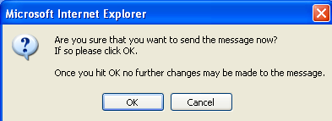

The completed message is sent to the specified healthcare provider via SCI Gateway. When the message is completed you are returned to the relevant Worklist and the status indicates that the message has been ‘Submitted’ as shown below.

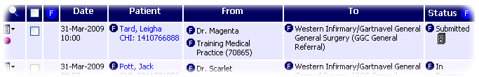

If you are managing your referrals with the worklist filtered for ‘In progress’ referrals the newly submitted referral will not be displayed. To see the referral open the full Referral Worklist, see Section 5

Sending a Back to Referrer message

When you send a back to referrer message if the ‘Update Original Referral Status’ tick box is selected the original referral will be updated with a status of ‘HEAT: Back to Referrer’

Saving Message Details to your Primary Care or Patient Management System
Details of ‘Submitted’ messages may be added to your Primary Care system however, you will need to be logged in to your primary care or patient management system when the message is being sent. For example, a copy of the letter may be saved to the patient’s record in your system or the patient’s history may be populated with details of where a referral was sent. Some systems will save details of advice responses, clinical dialogues and supplementary messages but not all systems.

See your system administrator for specific information regarding messages and what is imported to your system.

Saving a Copy of the Letter to Docman
If you have had the extra facility of ‘File messages in Docman’ added at the GP practice level, SCI Gateway will automatically save a copy of your referral or advice request letter to Docman. The submitted message will have a Filing Cabinet icon displayed in the worklist as pictured in the screen above.

See your system administrator for further information on having this facility activated at your practice.

Validating a Message
When you click on the Send button as described on page 3–29, the application checks the protocol to ensure all mandatory information has been included. If any mandatory details are missing, SCI Gateway may try to match the details available with details stored on the system.

Checking GP Details
If your protocol requires you to enter the Registered and Referring / Requesting GP / Clinician details manually, or extracts these details from your primary care system, the system will attempt to match these details. If any are missing from the following fields – Name, GMC Code, GP Code and Practice / Location Code – they will be checked against the details stored in SCI Gateway’s ISD Reference file.

Depending on the information entered in the relevant fields, a message box may be displayed requesting confirmation of the Registered and Referring GP details:

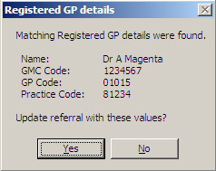
If these details are correct, click Yes to continue
If these details are incorrect, click No and amend the details in the protocol

Note: If your protocol uses drop down fields to select GP /clinician details then the message box pictured above will not be displayed, as using the drop down fields populates each of the fields used in the matching process.

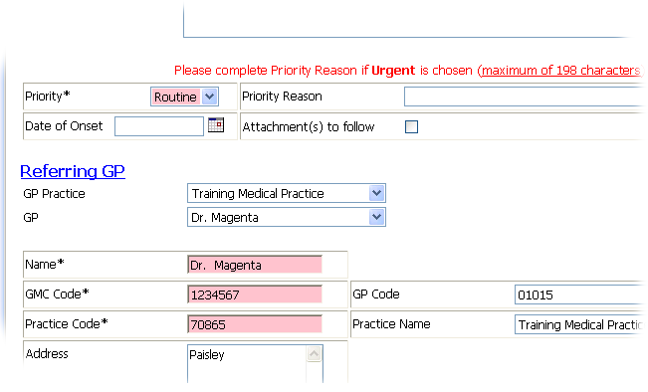
GP / Clinician drop down fields – select Practice / Location name and GP name from the drop down lists and all other details are filled in automatically

Checking Mandatory Fields
After the system has checked the Registered and Referring / Requesting GP / Clinician details as described on the previous page, it will check for errors or omissions in any mandatory fields.

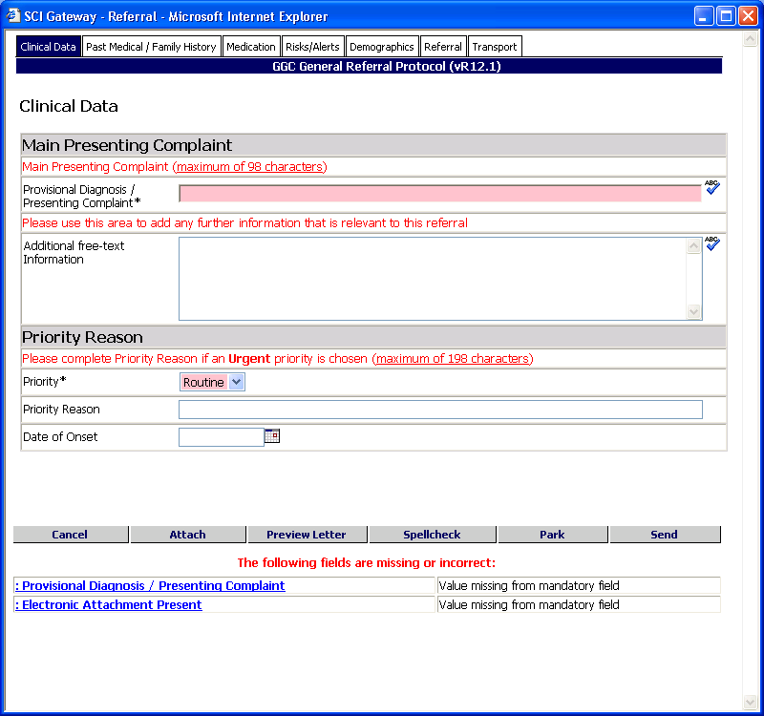
Click on the link to complete mandatory information

Details of missing or incorrect in mandatory fields are displayed at the bottom of the protocol – click on the link to jump directly to the field and amend as necessary and than click again on Send to send the message.

Creating a Supplementary Message
There are occasions when it is necessary to send additional information regarding a referral after the referral has already been submitted to the hospital / clinic. A supplementary message allows you to send the additional information, and links it to the original referral. This ensures the information reaches the hospital / clinic in a secure way and is already matched with the correct referral.

To send a supplementary message open the Referral worklist:

Click on the Context Menu icon next to the referral required

Select Send Supplementary from the Context Menu options

Details of the patient and message destination displayed here
Select the required Protocol from the drop down list
Click on Create

It is not possible to select a destination for the supplementary message as it must go to the same location that the original referral was sent.
Pictured below is an example of a supplementary protocol which is displayed after clicking on Create as described on the previous page:

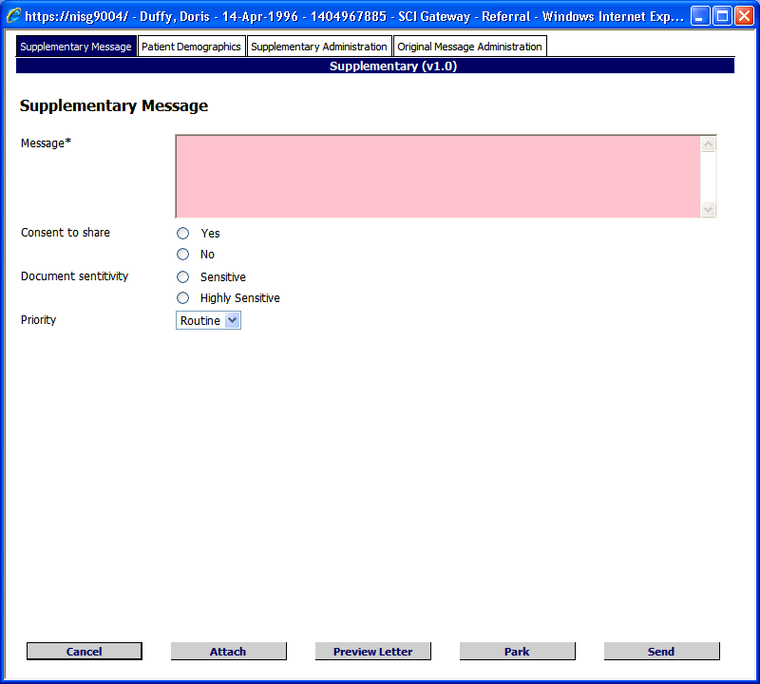
For details of information in other tabs see page 3-35
Enter information as required in the Message field

Click to Attach to add attachments
Click to Send

Click on Proceed
The following confirmation message is displayed when you click on Proceed as described on the previous page:

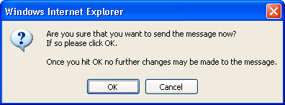
Click on Ok

On return to the worklist the Supplementary message is displayed with a status of Submitted.

Note: As with other protocols mandatory fields should be completed prior to sending. If you miss a mandatory field the following message will be displayed with a link to the missing information.

Supplementary Tabs

Tab Content | Function
Supplementary Message | Records details of the supplementary information – this field is mandatory – can be a simple message, for example, indicating that you have attached a lab result
Patient Demographics | Records details of patient’s name, address, CHI number, etc.
Supplementary Administration | Records the details of the Clinician sending the supplementary message
Original Message Administration | Records details of Clinician and practice / clinic address etc who sent the original message

Note: The protocol used in the example on page 3–4 is the NHS Scotland Supplementary protocol. Your local supplementary protocol may look different however the information you need to record will be similar.

If you have the option to ‘File messages in Docman’ will automatically save a copy of your supplementary message to Docman.

Some systems will save the supplementary messages in the same way as a referral message however, you will need to be logged in to your system when the message is being sent. Any questions regarding what is saved to the system should be directed to your system administrator.

It is not possible to send a supplementary message from New Message on the Menu bar. A supplementary message can only be generated from a previously sent message.

Receiving and Replying to Messages
When a user logs on to SCI Gateway they are able to access, view, print and manage all messages that have been sent and that they have permission to see. Generally speaking hospital /clinics receive referrals and GP practices receive discharges.

SCI Gateway provides users with the ability to generate and reply to some message types so that the end to end communication is carried out electronically ensuring that the patient data is sent and received in a secure manner. Currently you can receive and reply to advice requests with advice responses and eGPFR requests with eGPFR responses and clinical dialogues. This guide will use advice requests and advice responses to illustrate the functionality of receiving and replying to messages.

At this time the most common message type received are referrals in a hospital / clinic therefore this guide will use referrals to illustrate viewing and managing messages.

This section covers:

- Viewing New Messages
- Printing Messages
- Opening and Replying to Messages
- Letter Options
- Opening Individual Attachments
- Saving Messages to Docman
- Importing Discharges
- Sending Tertiary Referrals
- Redirecting Messages

Viewing New Messages
When you log on to SCI Gateway the home page is displayed and there will be a link indicating how many new messages you have received. In the following pages new referrals will be used to illustrate the functionality however the functionality will be the same for any message type received at any location.

New Messages – click to open the worklist required

Urgent messages are displayed higher in the new message worklist than most recent
Worklist is filtered to show referrals not yet printed / filed or ones that have had a reply created – see Section 5 for more information

Note: When you click on the link to show new messages, the worklist will be filtered to show only those messages that have been received but not yet printed.

See Section 5 of this User Guide for more information about filtering the Message Worklist.

Printing Messages

Bulk Printing
You can use the SCI Gateway bulk printing function to print all messages on the Message Worklist page, or a selection of messages, by following the steps outlined below. Alternatively you can print messages individually – see page 4–5.

1 | Click the tick box beside each message you wish to print – alternatively click the tick box in the column header to select all messages on this page of the worklist  Click here to select all or in the boxes to select individual letters | 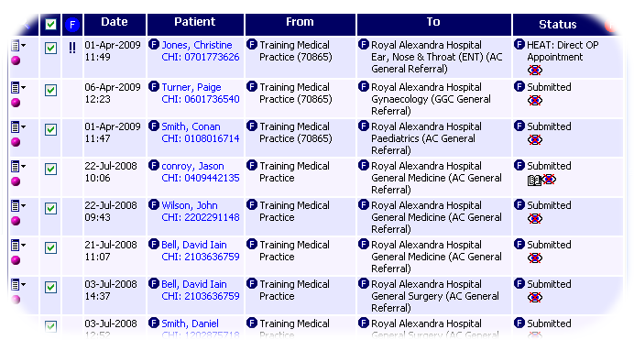
2 | The Print Attachments box is ticked by default – remove if required. Messages with attachments are indicated by the paperclip icon  Ensure Selected is displayed in the Print Letters drop down field  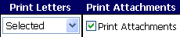 | 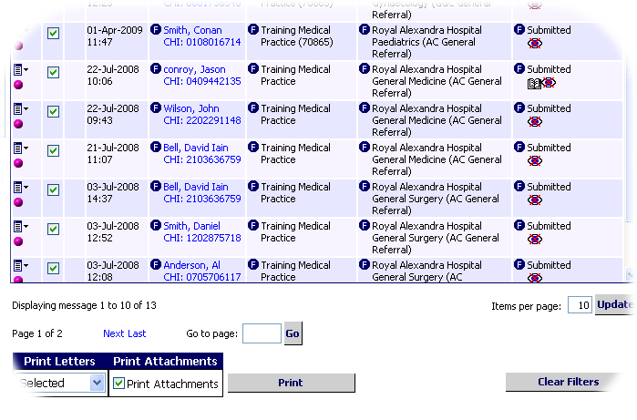
3 | Click on the Print button to print all selected referrals | 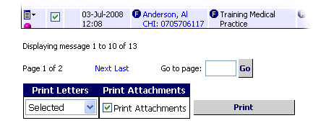

Messages that have been printed have the Printed and Viewed flags applied and therefore will no longer appear on the worklist unless you clear the filter– see Section 4 for more information on flags.
When printing multiple messages as described above, only certain attachment formats will be printed automatically – specifically .txt, .doc, .rtf, .tif, .bmp, .jpg and .gif. Other types of attachment can be viewed and/or printed individually for example, .pdf - see page 4-6.

Bulk Printing Confirmation Sheet
When printing multiple messages using the bulk print option, a Bulk Printing Results sheet itemising the messages that you have just printed will be produced at the end of the print run. It will also itemise number and type of attachments associated with the message.

Pictured below is an example of a confirmation sheet.

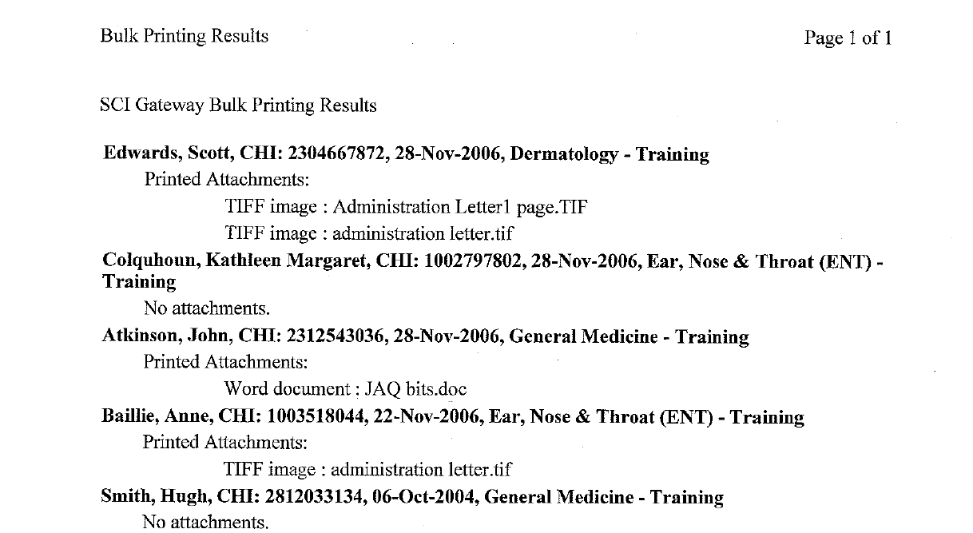
Attachments and file type itemised here below the name of patient
This message is displayed when there are no attachments

Opening And Printing Individual Messages
As an alternative to bulk printing messages as described on page 4–3, it is possible to view and print individual messages.

1 | In the Message Worklist click on the Patient name to open the letter  Click here | 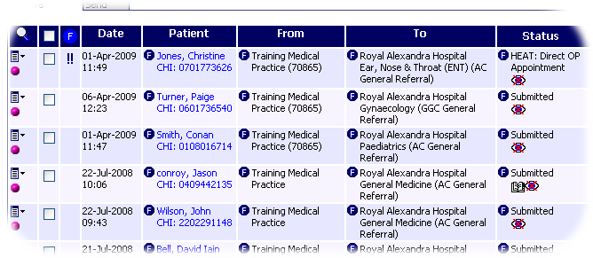
2 | The letter is displayed in a separate window – click on the Print button to produce a printout | 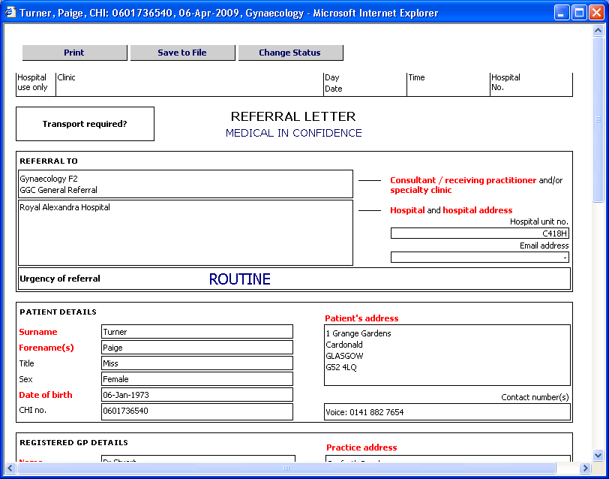
3 | Close the Preview Letter window by clicking on the Close icon – you will be returned to the Worklist | 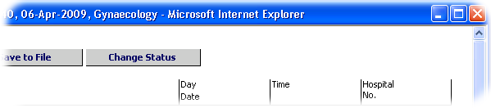

Note: If you print a letter as described above, any attachments will not be printed. Attachments can be printed separately – see next page.
When you open a new message, or print it individually or using bulk printing, the ‘Viewed’ flag is set which is seen by both the sender and receiver.
Opening a new message as shown in step 1 will not remove the message from the New Messages worklist.

Opening Individual Attachments
When bulk printing messages, you have the option to print attachments at the same time (see page 4–3). However, only some types of files will be printed using this method. You can open individual files that have been uploaded as attachments to referrals (and subsequently print them if required) by following the steps outlined below.

1 | Click on the paperclip icon next to the message to display the list of attachments  Click here | 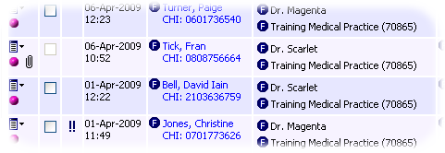
2 | The Message Attachments screen is displayed – click on the relevant icon to download the file | 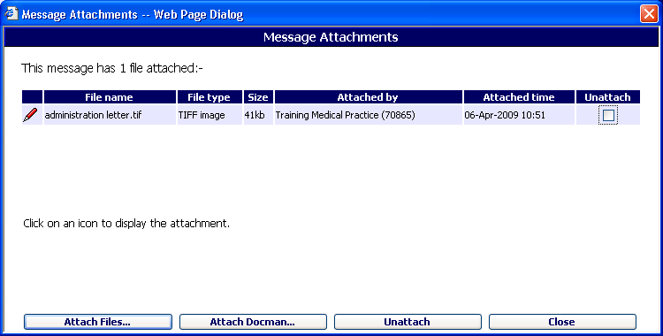
3 | In the File Download dialogue box, click on Open to open the file or Save to save the file to your computer  Click on Save | 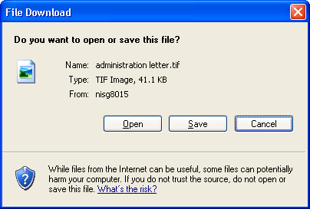
4 | To return to the Message Worklist click on Close  Click on Close | 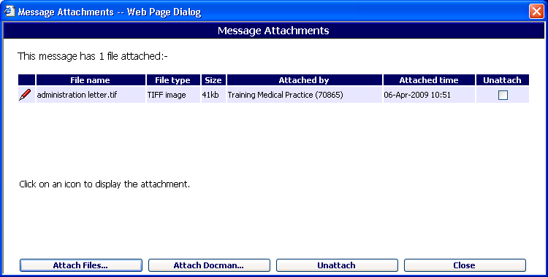

Opening And Replying To Messages
If a clinician receives an advice request or a clinical dialogue from a practice or another clinician, or a practice receives an eGPFR request from Department of Works and Pensions the advice response, the clinical dialogue response or the eGPFR response should be created and sent through SCI Gateway.

In the following pages an advice request and advice response will be used to illustrate the functionality of replying to a message. All options will be the same for replying to other message types unless otherwise stated.

Open the appropriate message worklist from the Menu Bar:

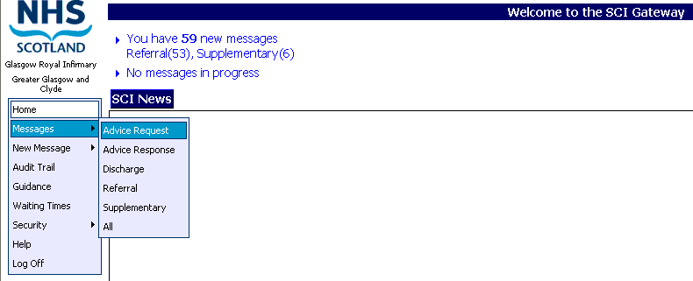
Point to Messages and select Advice Request

Click on the patient name to open the message
Right facing triangle denotes Advice Request

Note: New advice requests can be opened by clicking on the advice request link under the ‘You have x new messages’ link.
Pictured below is an example of an advice request message displayed after clicking on the patient name as described on the previous page.

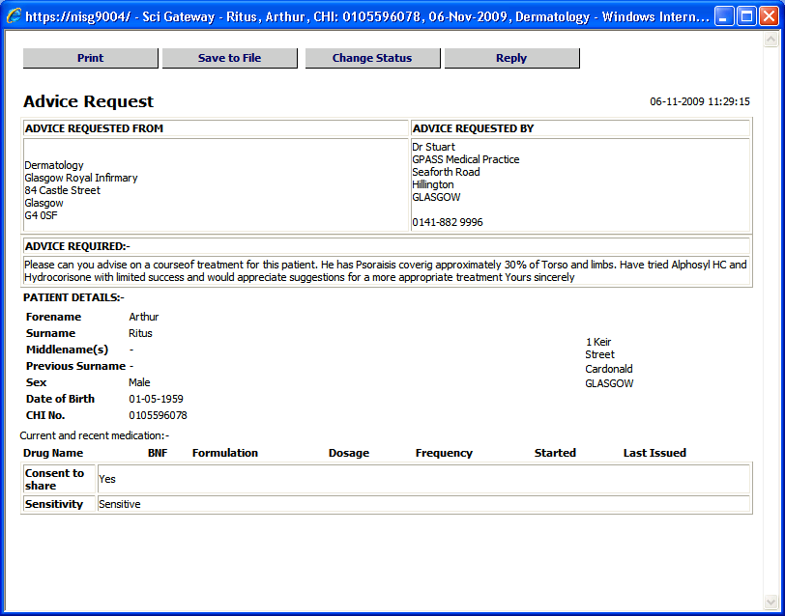
Click on Reply to respond to the advice request

The advice request closes and is replaced by an advice response protocol as pictured below.

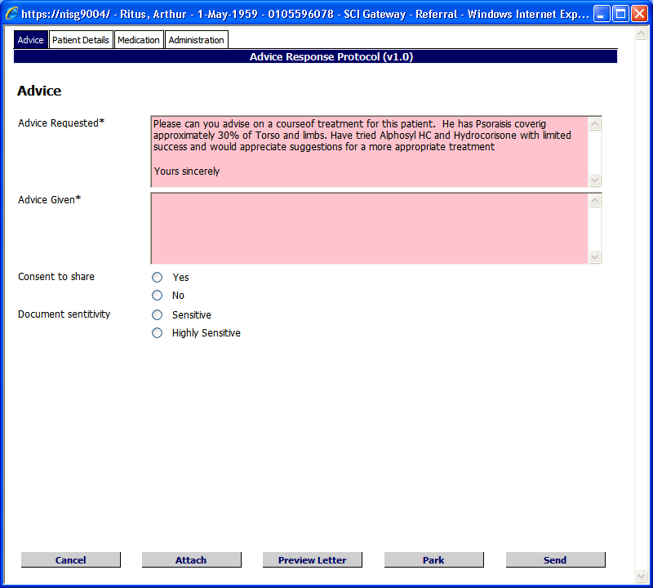
The original advice requested is displayed

Enter details of the advice response here
Select Consent to share and Document sensitivity options as required
Protocol buttons the same as other protocols

Pictured below is an example of an advice response protocol with mandatory information missing, displayed after clicking on Send as described on the previous page.

Click on the link to take you to the missing mandatory information in the protocol
Enter details in the blank fields or select the missing information from the drop down lists
When all information is complete click on Send

Click on Proceed

The message pictured below is displayed after clicking on Send as described on the previous page.

Click on OK to confirm

After clicking on Ok the Advice Request worklist will be closed and the Advice Response worklist is opened. The message will be displayed with a status of Submitted.

Advice response denoted by left facing yellow triangle

Advice Request / Advice response
The original request details, patient demographics, medication and requesting Clinician details are all pre-populated from the advice request letter.

The responding Clinician details are mandatory in an advice response and must be completed in the Administration tab.

When you click on Reply on an advice request letter the response protocol is generated and the original advice request is parked in the Advice Request worklist. When the advice response is sent the original advice request is deleted. It is not possible to reply to an advices response.

Mandatory information fields that need to be manually entered in an advice response are Advice Given and Sending Clinician details.

Clinical Dialogue
The original dialogue details, patient demographics and conditions / disabilities are pre-populated from the original clinical dialogue message when you create a new clinical dialogue message.

When you click on Reply on a clinical dialogue letter a new clinical dialogue protocol is generated and the original clinical dialogue is parked in the Clinical Dialogue worklist. When the new clinical dialogue is sent the original clinical dialogue is retained.

Clinicians can reply back and forward as often as they require to clinical dialogues.

eGPFR Request / eGPFR Response
The original request details, patient demographics and conditions / disabilities are pre-populated from the eGPFR Request letter.

When you click on Reply on an eGPFR request letter the eGPFR response protocol is generated and the original eGPFR request is deleted immediately. However, you can save the eGPFR request to the Batch Manager in Docman prior to clicking on Reply as described on page 4–8 if you want to save a copy of the eGPFR request.

It is not possible to reply to an eGPFR response.

Receiving Advice responses
When a Clinician replies to an advice response it will be displayed to the recipient in the SCI Gateway Home page under the link ‘You have X new Advice Responses’ as pictured below.

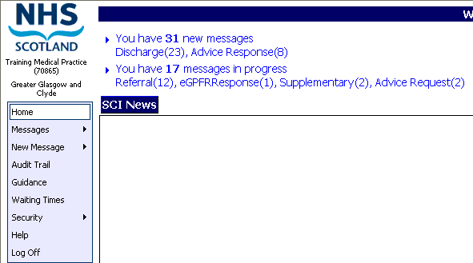
Click on the link to open new advice responses

Click on the patient name
Click on the option required to manage the advice response – see next page

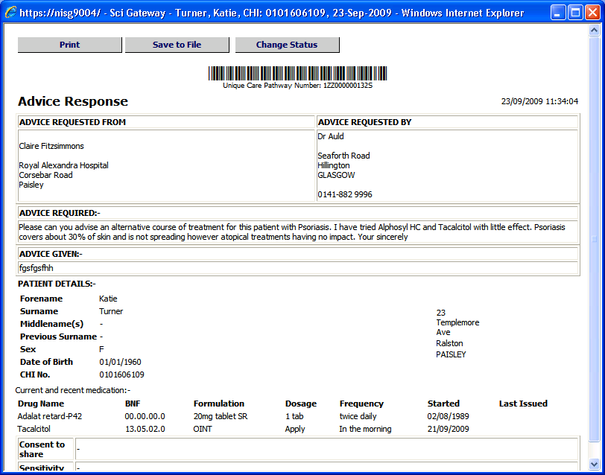

Letter Options

Print
Clicking here will print a copy of the letter.

Save to File
Clicking here allows you to save a copy of the letter for example, to a location on your PC or local network.

Save to Docman
Clicking on Save to Docman allows you to save a copy of the letter to Docman. Referrals, advice responses and clinical dialogues will save to the patient record at the point of sending through SCI Gateway, but can also be saved by clicking the button on the letter window.

Advice responses and discharges need to be seen by the GP so will save to the Batch Manager in Docman when you use this option.

A patient’s CHI number needs to be identified in a document in order to save it directly to the patient’s record in Docman. eGPFR request and eGPFR response messages do not contain the patient CHI number therefore it is not possible to save a document straight to Docman. You must save the file locally using the Save to File option and manage the message using Docman options, for example, drop a document. See your system administrator for more information on saving and managing documents in Docman.

Submitted eGPFR Responses
Submitted eGPFR response messages will automatically be saved to the batch manager of Docman if patient details are missing such as the CHI number, surname, forename and date of birth. If this happens a message will be displayed giving the details of missing / incorrect data:

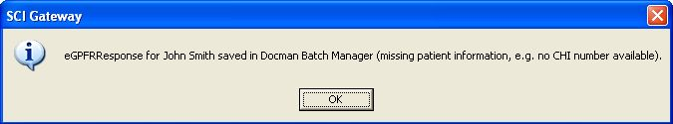
If an attachment is sent after the message has been submitted, and the message has been saved to the batch manager in Docman, a warning message will be displayed:

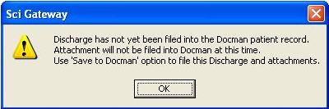

This is an example of a warning message displayed when a follow up attachment is sent after the original message could not be saved to the patient’s record in Docman due to missing patient information.

Change Status
Clicking here allows you to change the status of the message in the worklist for example, you may want to mark it as Filed after it has been seen by the GP / Clinician. See page 5–7 for more information on changing the status of a message.

In order to be able to view and manage received messages you must be included in a SCI Gateway Receiving HCE Group. See your system administrator if you are not receiving new messages that you should.

Bulk Saving Messages to Docman
Although messages can be saved individually to Docman as described on page 4–12, received messages can be bulk saved to Docman. Open the worklist by clicking on the link ‘you have xx received messages’

Click here to open received messages worklist

Click in the top box to select all messages on the page or click next to each message as required

Click on Save to Docman to save selected messages to Docman

The messages that you have selected will be saved to the Batch Manager in Docman. They will not be directly saved to the patients’ records. The messages in the worklist will then have the Filed and Viewed flags set.
After clicking on Save to Docman as described on the previous page a message will be displayed listing the message types and the name of the associated patients:

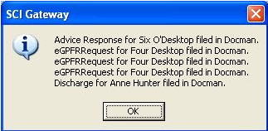
Click on Ok to continue

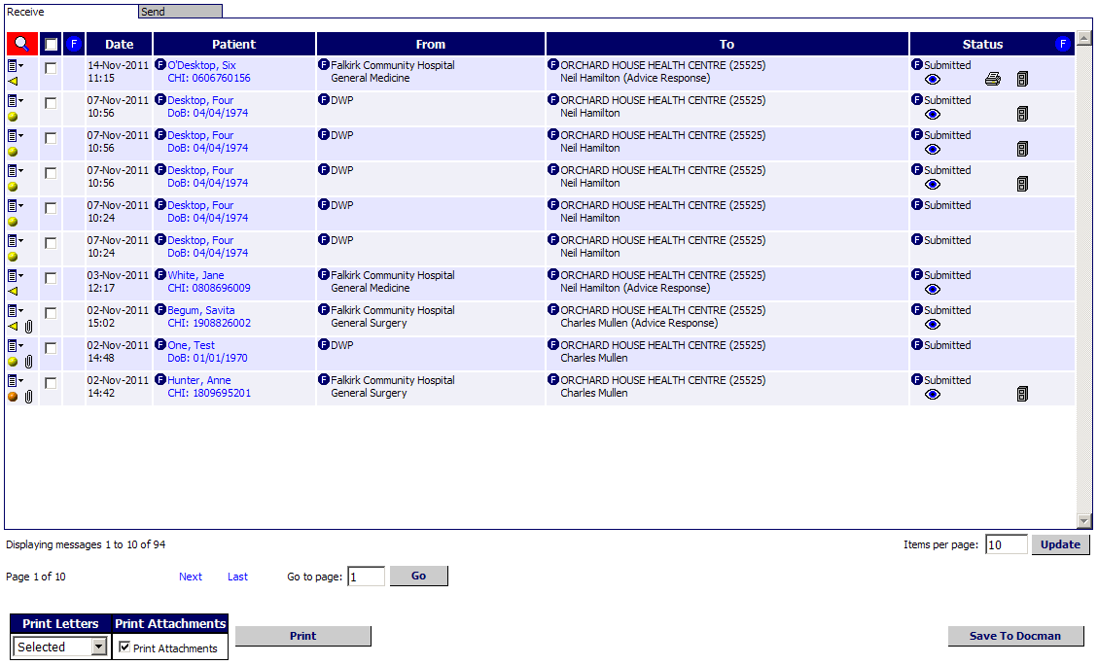
The Filed and Viewed icons are shown for the messages that have been saved to Docman

All selected messages will be saved in the same way to Docman as saving individually i.e. messages statuses updated and the filed and viewed flags set.

If the Save To Docman button is clicked for messages that already have the filed flag set then a message similar to the one below will be displayed:

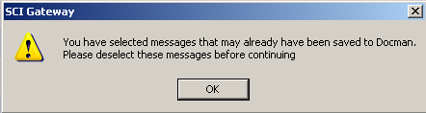

Importing Discharge Details Into Your Primary Care System
Information recorded in the discharge letter, for example, clinical diagnoses, can be imported into your primary care system if required. You must have your primary care system open and running on your PC in order to use the Import function.

1 | In the Discharge Worklist click on the Patient name to open the discharge letter  Click here | 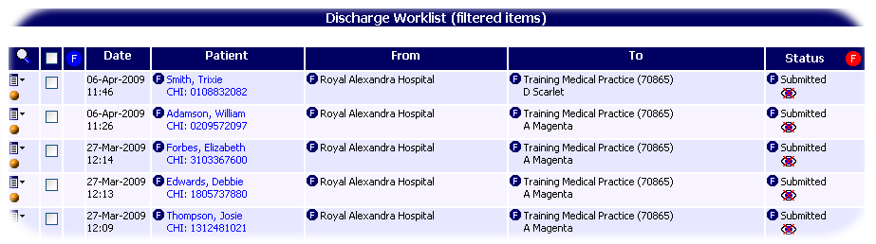
2 | The letter is displayed in a separate window – click on the Import button | 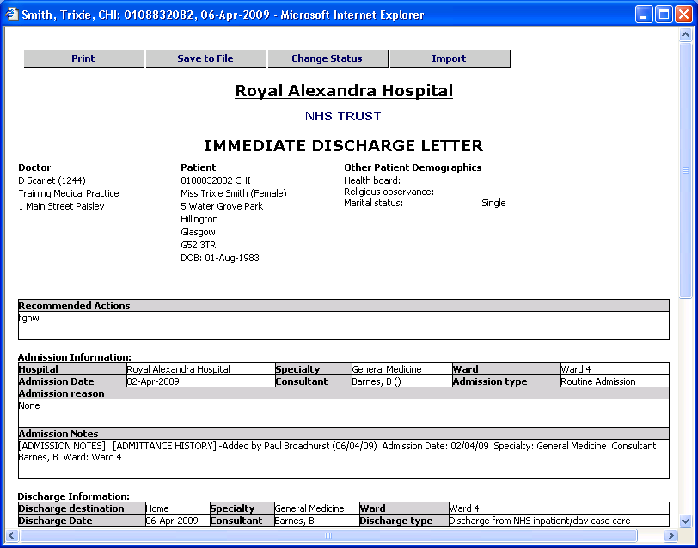

Note: If your primary care system is not running on your PC, a warning message will be displayed.

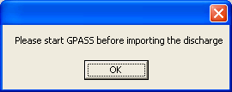
Example of warning message

Click on OK and log on to your primary care system before proceeding with the Import.

3 | The system will try to match the patient details in the letter to those in the practice’s database – click on Yes to confirm  Click here | 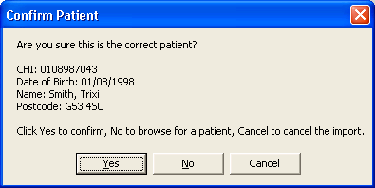
4 | If successful, the message box confirming the import will be displayed – click on OK  Click here | 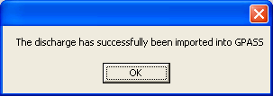

Note: Information and warning messages displayed during the import process may be different from those displayed in the screen above. If you have any queries regarding the import function please consult your system administrator.

Some primary care systems will import a copy of the discharge letter to the patient’s record. Contact your primary care system administrator for more information about importing details from SCI Gateway.

It is not possible to import any other message type to your primary care system. See page 3–30 for more information on saving messages.

Errors on Discharge Import
If there are any errors importing discharge information, the SCI Discharge Import Status Report screen pictured below may be displayed.

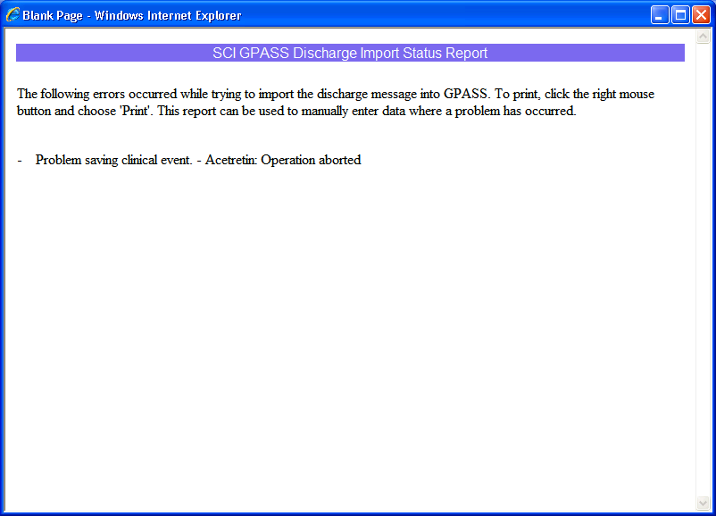

Click on the Close icon to return to the Discharge Worklist.

Note: If you receive an error message like the example displayed it indicates that your primary care system has not imported the data outlined in the message. If you want to include this information in the patient’s record you should enter it manually through the patient encounter windows in you primary care system.

Patient Details Mismatch on Discharge Import
If the system cannot match the patient details with a patient in the practice’s database, an information message box will be displayed:

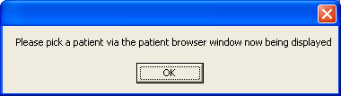
Click on OK to continue

Click on OK to confirm and search for the correct patient manually using your primary care system Patient Browser.

Your primary care system may be highlighted on your computer’s taskbar at the bottom of the screen – click on it to display the Patient Browser as in the example shown:

Click here to display the Patient Browser

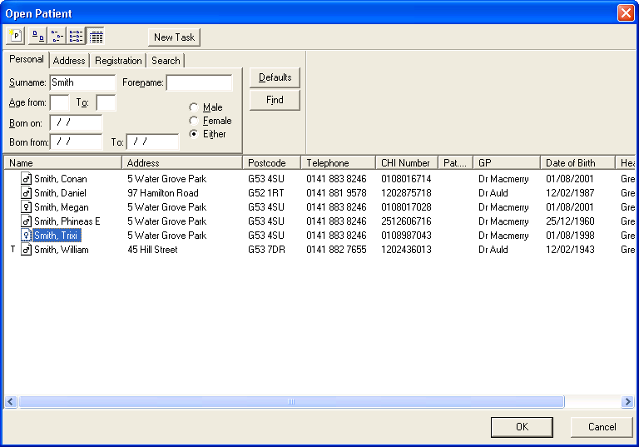
Search for and highlight the required patient and then click on OK

The discharge information will be imported into the highlighted patient’s record in your primary care system.

Redirecting Referrals
Once a referral has been received and vetted by a clinician there may be occasions when the most appropriate course of action is to redirect the referral to another specialty and / or location. You can redirect a referral to another hospital / specialty by following the steps outlined below:

1 | Click on the icon next to the referral you wish to redirect and select Redirect Referral…  Click here and then on Redirect Referral…
2 | Select the Health Board Area and destination options required or select from My Redirect Favourites list
3 | Click on the Redirect button at the bottom right-hand corner of the screen and then click on Yes in the Redirect box  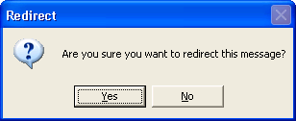 | 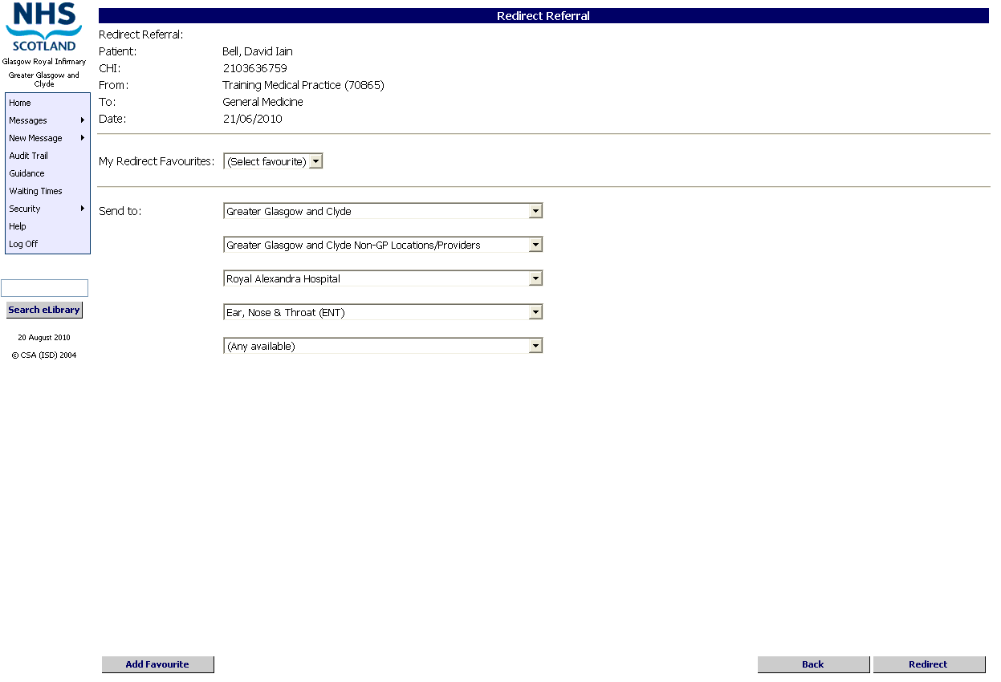

4 | You will be returned to the Referral Worklist and the redirected referral now has a new ‘To’ location if it is redirected to another department within your own permission range.  Redirected referral is not on the Referral worklist

Note: If the referral is redirected to a location out with your permission coverage it will not be displayed on your Worklist.

The date and time of when the referral was redirected will be updated in the worklist. See page 5–8 for more information on managing redirected referrals.

Creating A Tertiary Referral
There are a variety of reasons why tertiary referrals are made. For example, in order to ensure a patient is seen in a timely fashion they can be referred by their healthcare provider to another healthcare provider in an alternative location / health board. Alternatively, a clinician may require assistance from another clinician from a different specialty.

SCI Gateway has added a facility to allow healthcare providers to take the original referral and send it on to a new healthcare provider. When the original referral is used to make a tertiary referral, a copy is attached to the new referral and the patient demographics will be pre-populated in the relevant fields in the protocol.

To create a tertiary referral using the original referral, open your received referral worklist:

Select the required referral by opening the context menu .
Select Attach to new Referral…

Patient details are pulled across from the original referral
Select message options for the tertiary referral and click on Create

Note: Tertiary referrals can be created in the same way as other referrals, see Section 3 for more information on sending messages.

Back to Referrer
To create a back to referrer message you must find the original referral that you received. Select New Message|Back to Referrer from the Menu Bar you will be presented with the Back to Referrer: Choose Original Referrer window as displayed below:

1 search criteria to find patient
2 Click on Search

4 Deselect if you do not want to return the status of HEAT: Back to Referrer to the original referral on the worklist

3 A list of your patient’s referrals is displayed - click the box to select the referral to be returned
5 Select the protocol from the drop down list
6 Click on OK

After clicking on Ok the protocol window is displayed. Complete all information as required and send. For more information on completing a protocol go to page 3-13.

Managing The Message Worklists
You can manage all of your messages using the message worklists. You have the option to view all types of messages together or open individual worklists by selecting the option required for example, Referrals.

How you access the message worklists will differ depending on whether you are a hospital and use the SCI Gateway icon on your desktop or with a third party patient management system or if you are a GP practice and access with a primary care system.

This section covers:

- The Message Worklist
- Sorting the Worklist
- Filtering the Worklist
- Statuses and Flags
- Changing the Status
- Flags in SCI Gateway
- Flagging a Message as Filed
- Filtering on Status and Flags
- Searching the Message Worklist
- Cancelling and Deleting messages

The Message Worklist
Pictured below is an example of the Message Worklist. It provides a range of options to help you view and manage your referrals and other messages. You can access the full Message Worklist at any time by pointing to Messages and clicking on All on the navigation bar on the left-hand side of the screen. This will display all message types that you are configured for. Alternatively clicking on Referrals or any other option will open the specific worklist required.
Individual Filter icon – see page 5-5
Filter on status and flags icon – see page 5-13
Search icon – see pages 5-14 & 5-16
Click here for Context menu – see pages 5-16 & 5-17

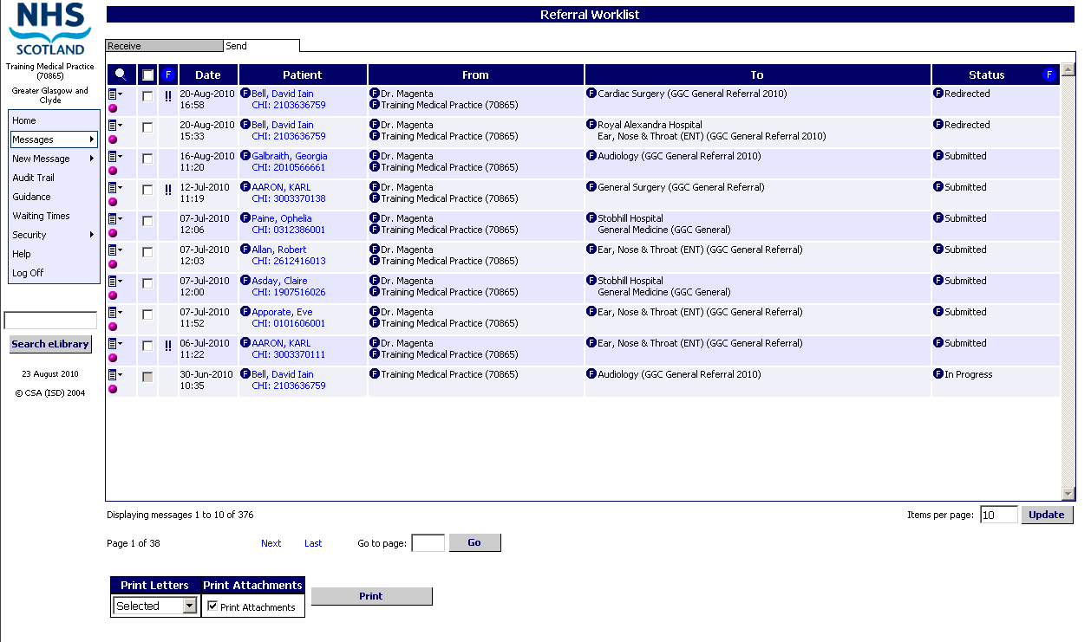

Printing options – see page 4-3
Click here to refresh the screen and view recent changes
Pink icon denotes Referral see page 5-3 for message type icons
Send & Receive tabs if other types of messages available (see below)

Note: If you have the capability to receive and send messages you will have the Send and Receive tabs displayed at the top of the worklist. The white tab is the active tab. On opening, the worklist is filtered to display messages for one month only.

Message Icons
Each different message type on SCI Gateway is denoted with a unique icon to make the message type easily identifiable.

Referral

Discharge

Advice Request

Advice response

Supplementary

eGPFR Request

eGPFR Response

Clinical dialogue

Back to Referrer

Sorting The Worklist
By default, information in the Message Worklist is organised by date and time. However, when you open your new message worklist Urgent suspected cancer and Urgent messages are displayed higher in the worklist than Routine messages sent earlier and are highlighted in the priority column.

You can sort the list according to your requirements by clicking on the relevant column header – in the example pictured below.

Click on the column header to sort the worklist

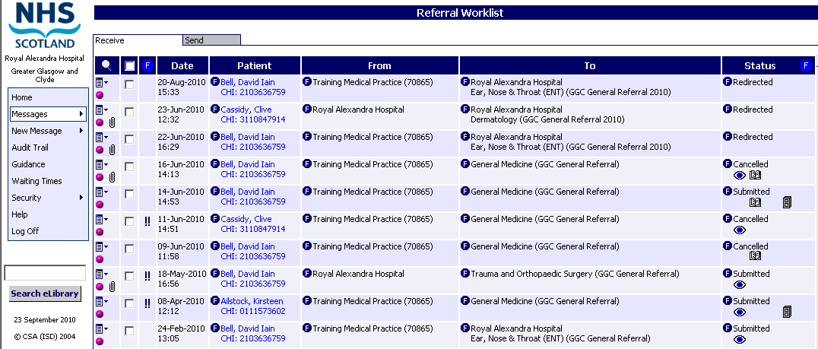
Priority of message denoted by icons or empty

Note: In the new messages worklist the urgent suspected cancer messages are displayed at the top of the worklist, taking precedence over more recent messages. See page 3–2 for more information on priority icons.

Arranging the Worklist by Priority
Once you have printed your new messages they are removed from the New Messages worklist and can be found by selecting a specific message worklist or the ‘All’ worklist. The usual order of date and time will be the default. You will have the option to filter or order the worklist to suit your needs.

Click on the icon to Filter/Order the worklist and then select option required

Order by priority
This option will reorder the worklist to show urgent and soon priority messages at the top.

Filter by priority
This option allows you to filter the worklist to show only Urgent – Suspected Cancer, Urgent, Soon, Routine or Advice messages depending on the option selected.

Clear Filters
This option allows you to clear any priority filter you have applied and display the full worklist.

Filtering the Worklist
You can click on any of the Filter icons to show only those messages containing the filtered item. For example, filtering on the GP name will only show messages for that GP – the Filter icon will turn red to show the filter has been applied.

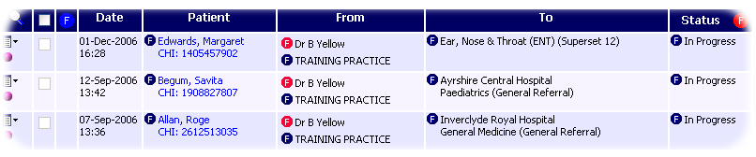
The list has been filtered by GP name

Note: You can have more than one filter applied at the same time. For example, if your Referral Worklist has been filtered to show only referrals for a selected GP you can further filter the list to only show In Progress referrals.

Removing Filters
You can remove individual filters that you have applied by clicking on the red Filter icon – other filters will be unaffected.

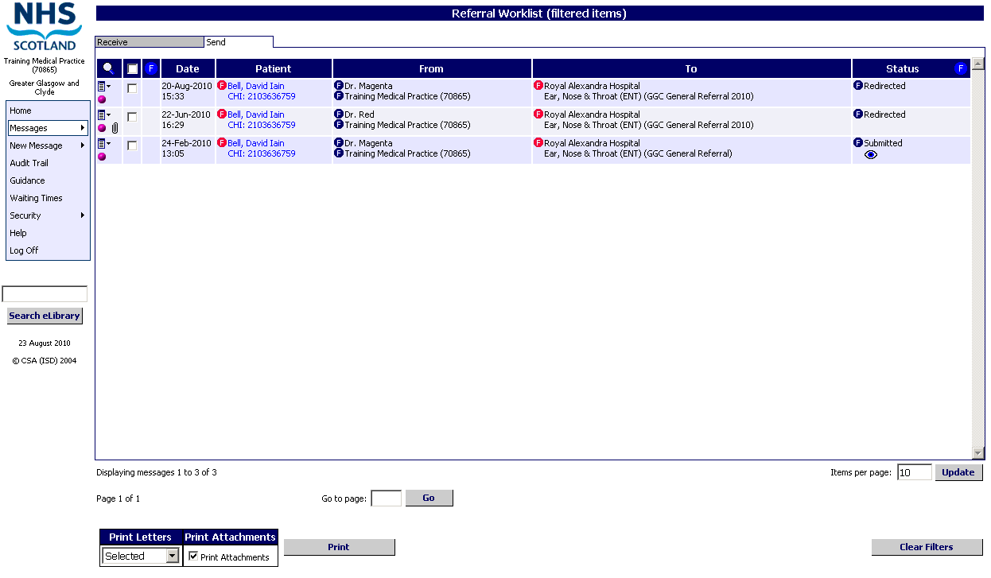
The list has been filtered by GP name and by specialty
Click on the icons to remove individual filters
Click here to remove all filters that have been applied to the worklist

Note: To remove all filters, click on the Clear Filters button as illustrated above. This option will also remove priority and status and flags filters – see page 5–14.

Care should be taken when filtering on GP / Clinician name. The name may differ depending on whether it has been typed into the protocol or pre-populated from a primary care / third party system or the ISD reference file, and only those referrals which exactly match the spelling and format of the GP name on which you have applied the filter will be returned.

Statuses And Flags
Statuses and Flags allow users to monitor the progress of messages accurately, both within the practice and hospital.

Status is displayed here. Flags that have been applied are indicated by the icons – see page 5-10

Statuses
Some statuses are automatically applied to messages, depending on what stage they are at in the process. For example, if a referral is parked before being sent, it will have the default In Progress status applied. When it is sent, it will have the default Submitted status applied. See page 5–9 for information on changing statuses manually.

SCI Gateway provides a default status of In Progress for messages not yet sent, and a default status of Submitted for messages that have been sent. It is possible for the local health board area to change these default statuses, although it is not recommended, as this may cause confusion when messages are sent between health board areas.
Health boards have the option to configure statuses which can be used to inform users of the progress of a message through its journey. For example, when an appointment has been scheduled for a referral the status may be changed by the hospital to show this.

Redirected Referrals
Once a referral has been received and vetted by a clinician, there may be occasions when the most appropriate course of action is to redirect the referral to another specialty and/or location.

When a referral is redirected on SCI Gateway to another specialty or location within the user’s permission range the associated details displayed in the worklist will change. The date and time will be changed to reflect when the redirection took place (i.e. when the referral was re-sent through SCI Gateway). The location and/or specialty will be replaced with the new details and the Status will indicate that the referral has been redirected. The actual wording may vary depending on the health board that is redirecting.

If the referral is redirected to an area outwith the user’s permission range the referral will disappear from the hospital worklist.

Pictured below is an example of a redirected referral. The name of the status may be different depending on the configuration of statuses in the health board area to which you have sent your referral.

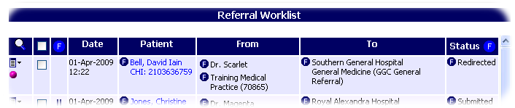
Location and/or specialty of referral will change
Status of the referral will change

Note: It is not possible for a practice to redirect a referral. See page 4–17 for more information on how to redirect referrals.

The facility to redirect a message can be configured for other message types.

Flags
Flags are designed to show what actions have been carried out against a message, either within the practice or by the hospital once the message has been submitted. Flags are usually applied automatically, for example, Printed when a practice prints a copy of a referral or an eGPFR request, or Viewed when the hospital opens, prints a referral or electronically generates a status change from a third party system.

You can apply a flag of Filed if you want to record the fact that a copy of the message has been kept. See page 5-11 for more information about the use of flags in SCI Gateway.

Changing The Status Of A Message
You can change the status of a message by following the steps outlined below. For example, you may wish to assign a different status for referrals that have been checked by the GP and are ready to be sent, or for the hospital to show that an appointment has been scheduled.

Additional statuses can be added by the health board area – they cannot be added to individual locations, only across all GP Practices or Non GP Locations/Providers in the area.

1 | Click on the Context menu next to the message you wish to change the status of and select Set status and flags…  Click here…  Then click here
2 | Select the status you wish to assign to the message from the Status drop down list  Click here to set | 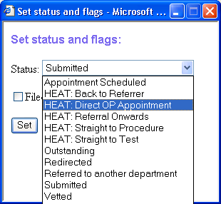  Click here and select the status required
3 | The screen will refresh and the message will be displayed in the Message Worklist with the new status
New status is shown here

Note: Changing the status of a message is only possible if SCI Gateway has been configured to allow this by the local health board area.

Once the message has been sent the status may be updated automatically depending on what the receiver does with it. Any changes to a status will automatically update the status in both the receiver’s and the sender’s Message Worklist.

Flags In SCI Gateway

Name | Icon | Icon – not set | How is it set? | What can it be used for?
Printed |  |  | Set automatically when printing a copy of the message. It is only visible to the location at which it was printed | If you want to ensure all messages have been printed for checking or filing, you can filter the worklist to show messages that have not been printed
Filed |  |  | Set manually by clicking on ‘Set status and flags…’ (see page 5–13) or set automatically if a copy of a message is saved to Docman | If you use this flag to note that a copy of the message has been filed, you can filter the worklist to show those referrals that have yet to be filed.  Will only set automatically if the location has ‘file to Docman’ functionality applied
Viewed |  |  | Set automatically when a location views, prints or changes the status of a received message | You can filter the Message Worklist to show messages that have been submitted but not Viewed by the receiving location and take appropriate action if necessary
Appointment Booked |  |  | Set automatically when a practice remotely books an appointment or by some outpatients management systems when an appointment is associated with a referral | You can filter the referral worklist to show which referrals have or have not had appointments booked

Sent | No icon | No icon | Set automatically when a message is submitted | If you use more than one status for In Progress messages to manage the workflow of messages, you can use the Sent flag to filter the worklist to show all messages not yet submitted
Reply Created | No icon | No icon | Set automatically when a location opens a message and creates a response electronically | You can use this option to look for messages that you have received but not yet replied to

Note: You can use any of the flags described above to filter the message worklist. See page 5–13 for more information on filtering the message worklist on statuses and flags.

The not set icons will only be displayed in the worklist when you open your new message worklist or when you apply the ‘Not Set’ options when filtering on status and flags on the Status column.

Flagging a Message as Filed
The only flag a location can manually apply themselves is the ‘Filed’ flag. For example, you may want to use this flag to record the fact that you have included a copy of the message in the patient’s notes.

1 | Click on the Context Menu next to the message you wish to attach a flag of Filed to and select Set status and flags…  Click here…  Then click here
2 | Enter a tick in the Filed tick box and then click on Set | 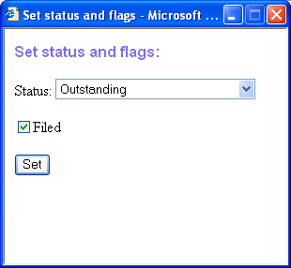  Click here and then click on Set
3 | The screen will refresh and the message will be displayed in the Referral Worklist with the new flag | New flag is shown here

Note: If required, you can repeat the above process to remove the ‘Filed’ flag from a message.

Filtering The Message Worklist On Status And Flags
As well as filtering directly by clicking on the icons as described on page 5–5, you can filter the Message Worklist using a combination of Statuses and Flags.

1 | Click on the Filter icon in the Status column header | 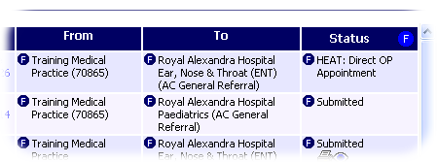
2 | In the Filter on Status and Flags window, select the Status you wish to filter on from the drop down list  Note: The Status drop down list will only show statuses that appear in the Message Worklist | 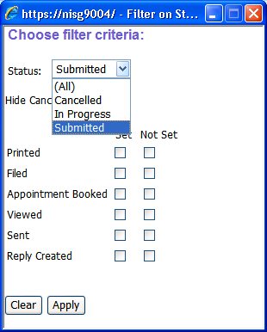  Click here and select the required status
3 | Select which flags you wish to include and which you wish to exclude. In the example given, only referrals that have been printed but have not yet had an appointment booked will be returned.  Note: The Hide Cancelled tick box can be used to exclude Referrals with a status of Cancelled | 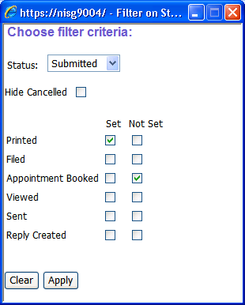  Select the flags you wish to include and/or exclude
4 | The red icon in the Status column header shows that the Referral Worklist has been filtered on Status and Flags.  The icons underneath the status show which flags are Set and which are Not set | 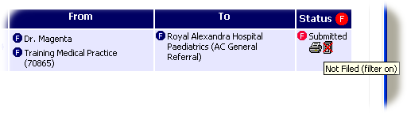  Icons show list is filtered to indicate referrals that have been printed but not filed  Hover the mouse pointer over an icon to see if the list is filtered on the associated flag – the cross through the Filed icon shows that this flag is NOT set

Searching The Message Worklist
SCI Gateway has a search function that allows you to search the Message Worklist by patient name, date range, CHI number and UCPN.

1 | In the Message Worklist, click on the Search icon
2 | In the search area, enter a date range and/or patient details  Note: The default date range is all dates up to today’s date – you can change the From and/or To date by clicking on the calendar icon | Enter search criteria here
3 | Click on the Search button to begin searching the worklist
4 | Search results are displayed – to return to the full worklist, click on the Clear Search button

Note: When you click on Search the system will search the entire Message Worklist. If you have filtered the Message Worklist prior to starting the search, then the search results will also have the filters applied – click on the Clear Filters button to see all search results.

Using The Restricted Search Function
When you open a message worklist which shows old as well as new messages, the search function is displayed by default. In the home page point to Messages and then click on the option required, in this instance Referral:

Point to Messages and then click on Referral to display the Referral worklist with the search function

The worklist is displayed showing messages for one month previous to the current date with the date range set in the search facility. To search for a patient, enter the patient’s name and / or CHI and click on Search.

To search for a patient outside of the set date range click on the calendar icons and reset the date:
Click here to open the calendar
First select Month & Year and then the day of the month required

Once you have selected an appropriate date range click on Search to display the results.

Cancelling And Deleting Messages
From time to time you may find it necessary to cancel or delete a message from the worklist. Follow the steps below to cancel or delete a message – in this example a referral.

1 | Click on the Context Menu and select Cancel Referral… or Delete Referral… as required (see below)  Note: The menu option will denote the message type selected in this instance referral  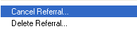
2 | Click OK to continue or Cancel to abandon cancelling or deleting the referral  Click here to continue | 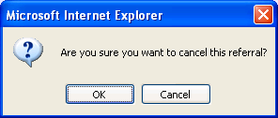
3 | If the message was cancelled, it will remain on the worklist with a status of Cancelled. If it was deleted, it will no longer be on the worklist and cannot be retrieved | Cancelled referral displayed here

Cancel
This option changes the status of the message to Cancelled. The message will remain on the worklist and can be accessed at any time.

Delete
This option ends the message and removes it from the worklist. You cannot access a deleted message, although details of all activity relating to it can still be viewed in the Audit Trail (see page 6–2).

Once a message has been submitted only the receiver can cancel or delete. All messages can be cancelled or deleted by the creator prior to being submitted.

Other Message Options
When you click on the Context Menu as described on page 5–2 a number of message options is offered to help you manage your messages.

Email
This option is not applicable at this time.
Email messages are not subject to the security measures used by SCI Gateway therefore it is essential that use of the email option conforms to the current national guidance on use of email for clinical messages.

Upload Attachment
You can attach files to a message by clicking on the Context Menu and selecting Attachments… from the menu. You will then have to navigate to the required file – see pages 3–20 to 3–24 for more information about uploading attachments to referrals.

Set status and flags
You can change the status of a message, or attach a flag of Filed to a message, by clicking on the Context Menu and selecting Set status and flags… from the menu. See pages 5–9 to 5–13 for more information about setting statuses and flags.

Other SCI Gateway Functions
SCI Gateway provides access to some other functions which you may find useful when using the application.

This section covers:

- The Audit Trail
- On-Line Help File
- Connect to E-Library
- Archiving

The Audit Trail
The Audit Trail allows users to view historical information regarding messages sent through SCI Gateway and uses similar search options to those available when using the search function in the message worklists.

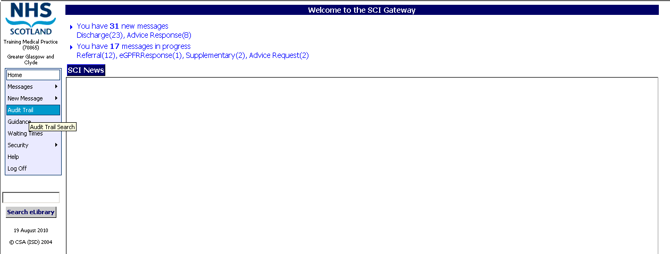
Click on Audit Trail to open

The Audit Trail search function is displayed with a default date range of one month as you would see in a worklist.

Select Message type and / or Event Type from the drop down lists
Default date range is one month from current date - change as required

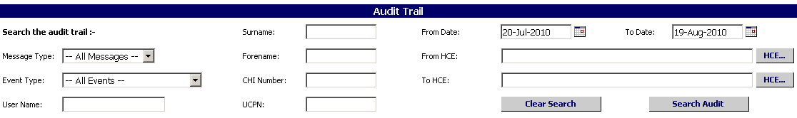
Enter details into Search fields as required
Click on the HCE… buttons to open the HCE Directory and select a location/specialty/clinician if required

Pictured below is the HCE Directory window which is displayed when you click on the HCE… button as described on the previous page.

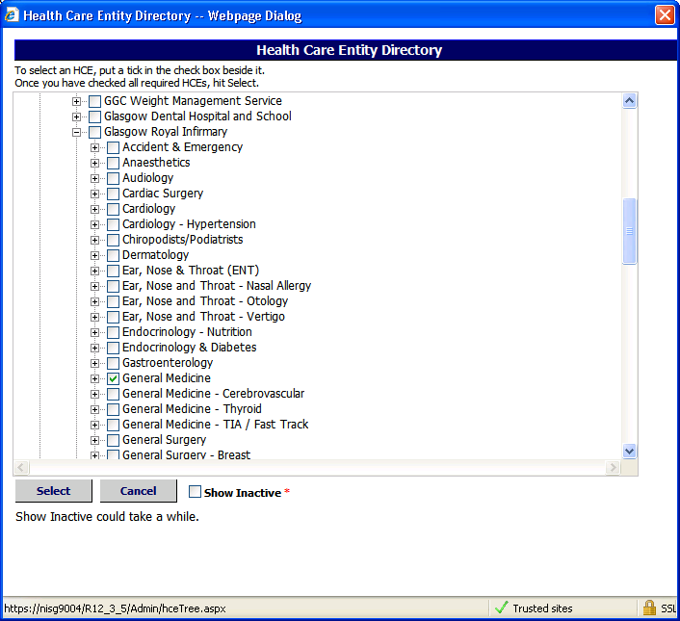
Click on the box to select an HCE
Click on the plus sign to expand an HCE
Click Select when you have selected your option from the HCE Directory

Click on Search Audit after selecting the criteria required

When searching on the From HCE… and To HCE…you can only have one HCE in each of the HCE… fields. For example, you can search for Referrals sent from one GP practice to one Specialty at a hospital.

If you select a hospital name you may not get any results returned and the message pictured below would be displayed. Messages are generally sent directly to Specialties or Consultants on SCI Gateway rather than the actual hospital.

Pictured below is the result of the search carried out in the example on the previous page:

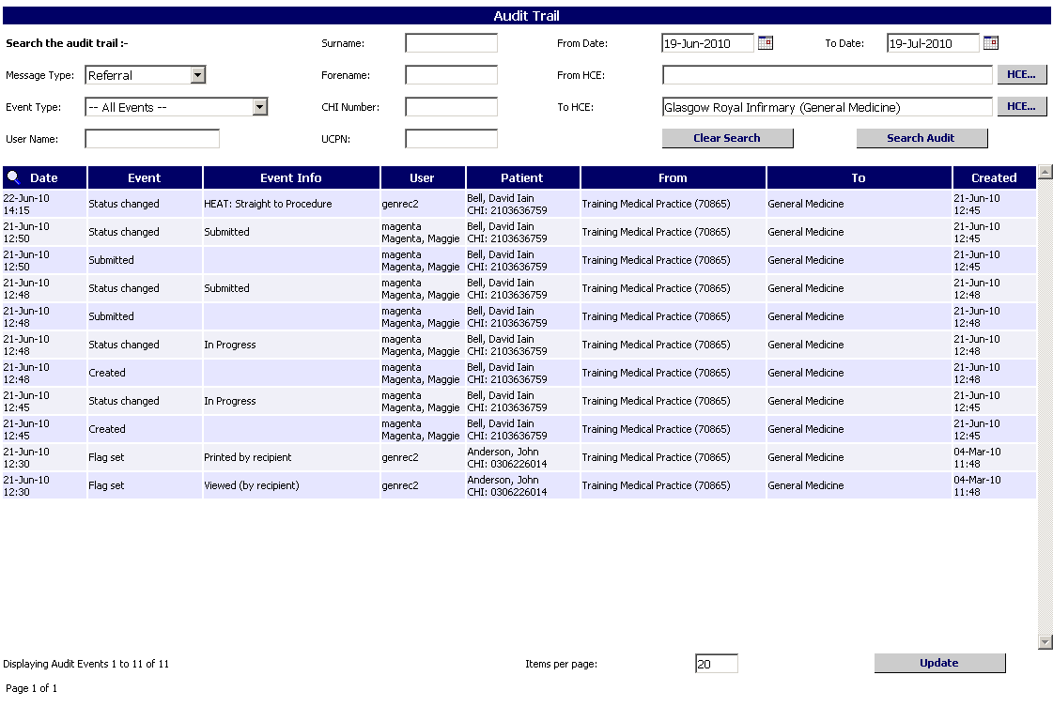
User name, surname and forename displayed here

Number of events that occurred
Number of pages of results
Number of items per page – default 20
Click here to refresh the screen after making changes

In order to improve management and identification on SCI Gateway, users demographic information recorded against their user account will be displayed. This allows the Audit Trail to display more information.

When a search is run on the Audit Trail, the results will display the first name and surname as well as the user name of the relevant users.

If you have more than one page of search results the bottom of the audit screen will look as below:

Enter the page number required and click on Go

Note: The Results are displayed in date and time order like the worklist.

The update button can be used if you change the number of items per page or make a change to the search criteria.

Clicking on the magnifying glass icon will close the search criteria window but the results of your search will remain displayed on the page.

Clicking on the Clear Search button will clear all search criteria and the results from your search but leave the window open.

To search on a date range of one specific day the From and To dates should have the same date.

Audit Trail Search Criteria

Message Type
Allows you to search by message type for example, referral, advice response etc.

Event Type
Allows you to search by different actions that have taken place when creating, sending and managing messages.

Attached to message | A submitted message was attached to a new message using the ‘Attach to new’ option. The audit record is for the original submitted message e.g. an original referral was attached to a new tertiary referral
Cancelled reversed (recipient) | A message that had been cancelled by a recipient web server was reinstated
Cancelled (recipient) | A message was cancelled by a recipient web server e.g TrakCare
Created | A message was created
Deleted (recipient) | A message was deleted by the recipient
Docman attached | A document from Docman was attached to a message
File attached | A file was attached to a message
File Unattached | A file was unattached from a message
Flag set | A flag was set on a message e.g. Filed icon
Flag unset | A flag was unset from a message e.g. Filed icon
Message attached | A submitted message was attached to a new message using the ‘Attach to new’ option. The audit record is for the new message e.g. an original referral was attached to new tertiary referral
Message attachment attached | A submitted message that had an attachment was attached to a new message using the ‘Attach to new’ option e.g. a referral with an attachment was attached to a new tertiary referral. If the original referral has more than one attachment there will be an audit record for each attachment
Redirected | A message was redirected to another healthcare provider

Redirected (recipient) | A message was redirected to a recipient web server e.g. TrakCare
Saved to Docman | A message was saved to Docman
Status change | The status of a message was changed
Submitted | A message was submitted
Submitted (recipient) | A message was successfully sent to a recipient web server e.g. TrakCare
Submitted redirect (recipient) | A redirected message was sent to a recipient web server e.g. TrakCare

User Name
Allows you to search for actions carried out by a specific user.

UCPN
Allows you to search by the UCPN – the patient’s referral Unique Care Pathway Number.

CHI
Allows you to search by the patient’s CHI number.

Forename
Allows you to search by the patient’s first name.

Surname
Allows you to search by the patient’s last name.

From Date - To Date
Allows you to search through a date range. If you choose All Messages the date range is restricted to one day. The following message will be displayed if you attempt a search on a longer date range.

From HCE... to HCE…
Allows you to search for the location or clinician that was responsible for sending a message or that received a message. Clicking on the button will display the HCE directory.

Help
SCI Gateway has an On–Line Help file which provides guidance on the installation and use of the application.

Click on Help to open the On-Line Help file

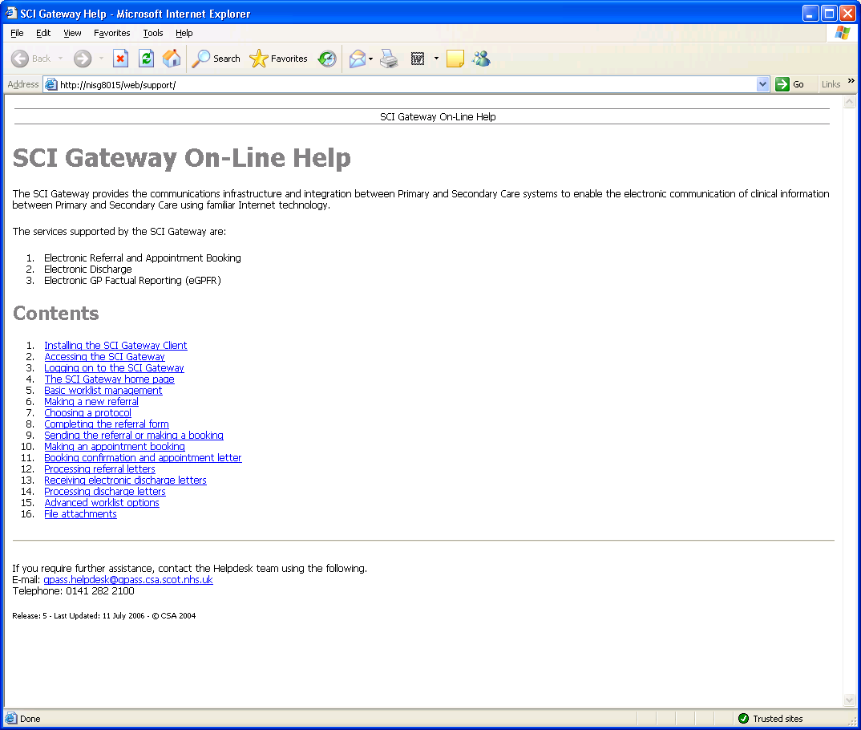
Click on a link to open the relevant Help page

Note: SCI Gateway On–Line Help will open in a separate browser window when you click on Help on the Gateway home page.

Navigating the On-Line Help File
The topic you selected from the Help home page is displayed when you click on the link as described on the previous page.

Click on the and buttons to navigate to other pages
Click on the button to return to the Help home page

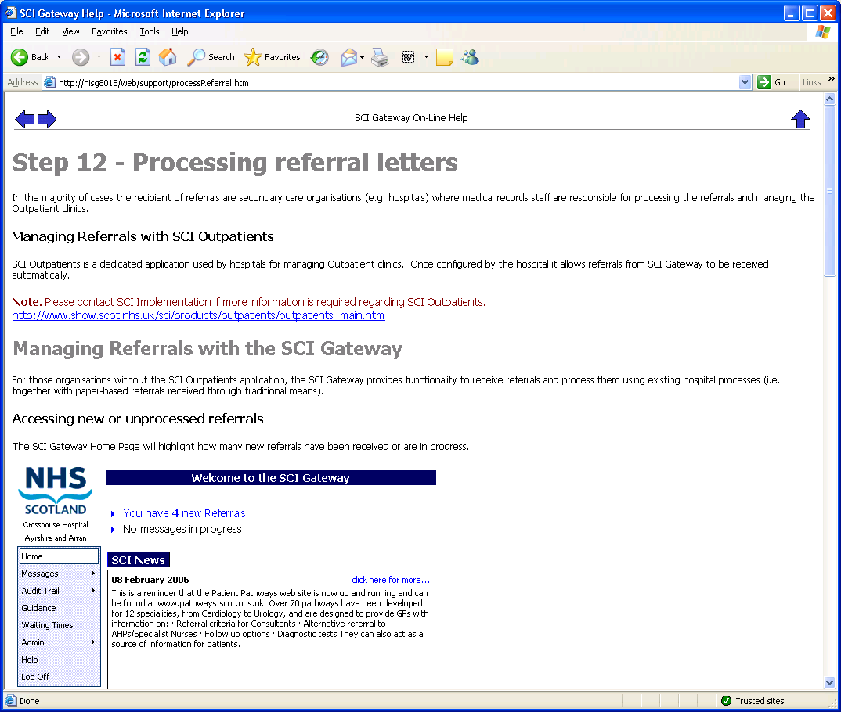

Connect to eLibrary
The Search eLibrary button below the main menu bar allows you to connect to the eLibrary and search for referral guidance.

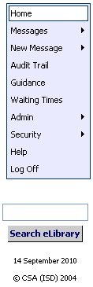
Type your keyword search in the field
Click on Search eLibrary

When you click on the button as described above it will launch the eLibrary website in a separate browser with your search criteria. When you are connected to the eLibrary web pages your search results will be displayed as pictured below.

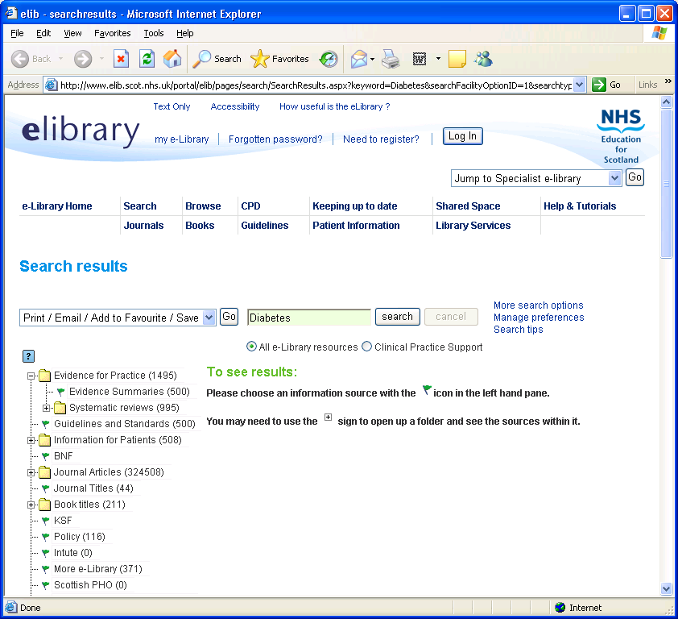
You can use any of the links on the eLibrary pages to find further information on your search.

Archiving
SCI Gateway is not designed to hold messages indefinitely therefore, there is an automatic archiving / deleting of messages that are older than nine months.

Messages older than nine months will be archived / deleted from the worklist on a monthly basis when they reach the time limit of nine months old and will not be retrievable through SCI Gateway or from NISG. Therefore, you should always ensure that there is an electronic copy of your messages stored where possible.

Saving Copies of Messages
Individual health boards will be responsible for the long term storage of messages that are sent via SCI Gateway. It should be noted that SCI Gateway is not the sole location for messages and that they can be saved to many GP and third party systems, for example:

- Most GP practices have for some time saved copies of their referrals to Docman and should continue to do so. If you do not have this facility contact your local primary care system administrators.
- A number of health boards have a facility set up where copies of messages sent and / or received within their control are saved in their local SCI Store. If you are unsure if your health board saves copies of your messages please contact your system administrator.
- Some hospitals and healthcare providers save electronic copies of their messages and some only save paper copies. If you have concerns about saving electronic copies please contact your local system administrator.

- Messages that have not been sent and are older than nine months will be archived / deleted along with all submitted messages.
For information about saving messages in SCI Gateway see Section 3.

Index

A
Accessing SCI Gateway · 1-2, 2-1, 2-2
Adding an Attachment to a Message · 3-26, 3-28
Advice · 3-19
Advice Request /Advice Response · 4-10
Archiving · 6-11
Audit Trail · 5-17, 6-1, 6-2, 6-4, 6-5, 6-6
B
Bulk Printing · 4-3, 4-4
C
Cancelling And Deleting Messages · 5-17
Change Status · 4-15
Changing the Status of a Message · 5-9
Checking GP Details · 3-33
Checking Mandatory Fields · 3-34
CHI and RTT Pathway · 3-9
CHI Demographic Matching · 3-6
CHI Look up through SCI Store · 3-10
CHI Matching with RTT · 3-8
CHI No Match · 3-11
Clear Filters · 5-5, 5-6, 5-15
Clinical dialogue · 4-10
Commonly Used Tabs · 3-13
Completing A Protocol · 3-12
Creating A New Message · 3-2
E
eGPFR Request / eGPFR Response · 4-11
E-Library · 6-1, 6-10
Errors on Discharge Import · 4-20
F
Filtering the Worklist · 5-1, 5-5
Flags · 5-1, 5-7, 5-8, 5-10, 5-13
G
Generating & Sending Messages · 3-1
H
Help · 3-13, 6-1, 6-8, 6-9
Homepage · 2-1, 2-10
I
Importing Discharge Details into your Primary Care System · 4-18
Interactive questions · 3-14
Types of interactive questions · 3-15
L
Letter Options · 4-1, 4-14
Logging on to SCI Gateway for the first time · 2-4
M
Message Icons · 5-3
My Favourites · 3-4, 3-5
O
Opening And Printing Individual Messages · 4-5
Opening Individual Attachments · 4-1, 4-6
P
Parking A Message · 3-25
Passwords · 2-12
Previewing & Printing The Letter · 3-24
Printing Messages · 4-1, 4-3
Priority · 5-5
Priority of referrals · 3-19
R
Receiving Advice Responses · 4-12
Receiving and Replying to Messages · 1-2, 4-1
Redirected Referrals · 5-8
Redirecting Referrals · 4-22
Referral to Treatment · 3-13
Removing Attachments from a Message · 3-30
Removing Filters · 5-6
Reply to Advice Response · 4-7
Reply to EGPFR Request · 4-7
Replying To Messages · 4-7
Restricted Search Function · 5-16
Routine · 3-19
S
Save to Docman · 4-14
Saving a Copy of the Letter to Docman · 3-32
Saving Copies of Messages · 6-11
Saving Message Details to your Primary Care System · 3-32
Security Questions · 2-5, 2-7, 2-9
Sending The Message · 3-31
Soon · 3-19
Spell Checker · 3-20, 3-22
Statuses And Flags · 5-7
Supplementary Message · 3-35, 3-37
T
Tertiary Referral · 4-24
The Message Worklist · 5-1, 5-2, 5-13, 5-15
The Protocol Window · 3-12
U
Upload Attachment · 5-18
Urgent · 3-19
Urgent –Suspected Cancer · 3-19
User Reset Password · 2-8
V
Viewing New Messages · 4-1, 4-2

