
SCI Gateway
Version 17.0 Release Notes
The purpose of these Release Notes is to highlight the changes to SCI Gateway that occur in version 17.0.

The major changes are listed on pages III to VII – What’s New in SCI Gateway version 17.0. Further details are provided on subsequent pages where appropriate.

What’s new in SCI Gateway version 17.0 for End Users

1 | Interactive Protocols  There are new protocol forms which may request additional information / questions depending on how you have responded to a previous question.  See page 2
2 | Clinical Dialogue Message  This is a new message type which will allow clinicians to have a clinical dialogue through SCI Gateway in a similar way to replying back and forth to email communications.  See page 5
3 | Back To Referrer Message  This is a new message type which will allow a clinician to return a referral back to the referrer and give detail of the reasons for the return.  See page 17
4 | Advice Response Sending HCP Pre-population  Healthcare professionals sending Advice Responses will now have their details pre-populated in the protocol.  See page 22
5 | Sending Messages From Secondary Care IT Systems  Users in Non-GP Locations i.e. hospitals and clinics can now send messages through SCI Gateway from their third party IT systems. Patient demographics and medical history will pre-populate protocols.  See page 24
6 | Static Horizontal Scroll Bar on Protocol Forms  Protocols have been changed so that there is one horizontal scroll bar at the bottom of a protocol instead of one under each section in a table.  See page 30
7 | GP Selected in Primary Care System pre-populates Protocol  GP Practice users will not have to reselect the sending GP in the protocol if they were previously selected in the GP IT system.  See page 32
8 | Known Issue and Fixes  There are known issues in V16 of That have now been fixed in this release  See pages 33
  & | < | > | | | ~ | ¬ | ‘
9 | Reduction of Interruption to SCI Gateway Service  There has been a change to how the ISD Upload is run which means that users of SCI Gateway will not lose access when this is updated every week and can continue to send and view messages.

What’s new in SCI Gateway version 17.0 for System Administrators

1 | Interactive Protocols  There are new protocol forms which may request additional information / questions depending on how you have responded to a previous question.  See page 2
2 | Clinical Dialogue Message  This is a new message type which will allow clinicians to have a clinical dialogue through SCI Gateway in a similar way to replying back and forth to email communications. This will require configuration as you would with any other message type.  See page 3
3 | Back To Referrer Message  This is a new message type which will allow a clinician to respond to a referrer with feedback when the patient is being returned to referrer.  See page 11
4 | Show Coverage of HCE and Users  A new option has been added to the NHS Directory which when selected will show all the users who can see messages either received or sent from the HCE being viewed.  See page 20

5 | Sending Messages from Secondary Care IT Systems  Users in Non-GP Locations can now send messages through SCI Gateway from their third party IT systems. Patient demographics and medical history and referrer details will pre-populate the protocols.  See Page 20
6 | Advice Response Pre-population of HCP  Healthcare professionals sending Advice Responses will now have their details pre-populated in the protocol. New protocol XML questions are available which will facilitate this functionality.  See page 27
7 | Destination URLs-Modify Capability  A new capability that allows administrators to edit Destination URLs is now available.  See page 29
8 | Destination URL - Owner  Destination URLs must now have an Owner assigned to them in the same way as protocols and stylesheets.  See page 34

9 | National Optometry Branches  This branch has now been added to the NHS Directory. The status of the branch is “Inactive” and the HCEs within the branch will need to be configured in the same way as any other HCE.  See page 37
10 | Consistent Status IDs  There is a new method of setting message statuses that specifies that the statuses are set in a consistent manner across the different SCI Gateway environments.  See page 39
11 | GP Selected in Primary Care System pre-populates Protocol  When a GP is selected in the primary care system their details are automatically pre-populated in the protocol. This requires protocol XML change.  See page 40
12 | Read Codes in XML  It is now possible for third party IT systems to retain Read codes that are sent through XML.  See page 41
13 | New Protocol Verification Tool  A new PVT has been developed which emulates the recent changes in protocols and SCI Gateway.  For more information on the PVT see NISG Support.

End User Changes

Interactive Protocols
There are new questions available in protocols that when answered in the appropriate way will display further questions and allow the sender to expand on the information requested. These protocols are opened in the same away as you would previously, depending on the message type being sent.

Pictured below are examples of interactive questions in a referral protocol. In this example a referral protocol has been opened after selecting the message destination options and clicking on Create in the New Referral window:

Priority Question
Interactive question
Select Routine and the Priority Reason is not a mandatory field and is greyed out and unavailable

Interactive question
Select Urgent and the Priority Reason becomes a mandatory field and must be completed

Date of Birth Question
Interactive question
Date of birth – if the patient is older than 10 years of age the next field is greyed out and inactive

Interactive question
Date of birth if the patient is less than 10 years of age the next field is mandatory and Parent’s Guardian must be completed

Types of interactive question
The following tables give examples of different types of interactive questions and the different ways which they may be displayed:

Question | Action
Does the patient have mental health issues? | If you select the “Yes” option a further field may be activated or displayed asking for more details
Has the patient had X-rays taken? | If you select the “Yes” option a further field may be displayed asking for more details e.g. asking where they were taken, if they have been sent by post or where they are stored
Is the patient under 17 years of age? | If you select the “Yes” option a further field may be displayed asking details of the responsible parent/guardian

Question | Style | Action
Questions may take the form of pre-populated information as in a date of birth field |  | The question is already answered and the user needs to complete the following questions / fields
Questions may take the form of a radio button |  | The user will make a selection and new questions / fields may be activated or displayed
Questions may take the form of drop down lists |  | The user will make a selection and new questions / fields may be activated or displayed

The above are just a few examples of the interactive questions available. There may be many more depending on the options used by your local health board protocol authors
Interactive protocols may not immediately be available on upgrade to v17.0. For more information about interactive protocols contact your local system administrator.

Clinical Dialogue Message
This new message type will allow clinicians to have a discussion regarding a patient. It provides the functionality to be able to reply back and forth for as often as required in a similar way to sending and replying to emails. To create a clinical dialogue message find your patient and log on to SCI Gateway from your third party system:

Point to New Message and select Clinical Dialogue

Select message destination options from the drop down lists

Select your protocol
Click here to create a favourite for the destination
Click on Create

Pictured below is the Clinical Dialogue window displayed after clicking on Create as described on the previous page:

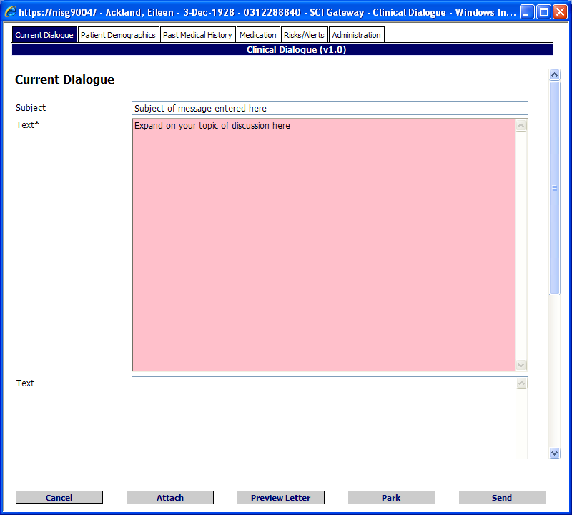
Enter information here
Click on Administration tab to complete the sending clinician details
Click here to cancel
Click to add an attachment
Click to preview the letter
Click to close and save for later
Click here to Send

Click on Proceed to continue
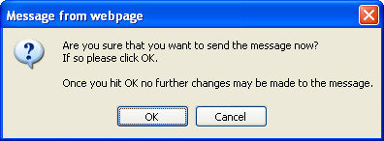
Click on OK to continue
Click on Cancel to go back

On return to the worklist the message that you have sent is displayed at the top of the list.

Clinical dialogue messages are displayed with a speech bubble icon.

The messages will be displayed in date and time order in the same as with other message types.

Replying to a Clinical Dialogue Message
You will receive a clinical dialogue message in the same way as you would receive a referral or a discharge. To open a new clinical dialogue message click on the link . The worklist will be displayed with your clinical dialogue messages shown:

Click on the patient’s name to open

Alternatively, you can to reply by opening your received clinical dialogue message worklist from the Menu bar if you have previously viewed the message. When replying to a clinical dialogue message any previous conversation elements i.e. the original details need to be quoted.

Point to Messages and select Clinical Dialogue

Click on the patient’s name to open

Pictured below is your received clinical dialogue message displayed after clicking on the patient’s name as described on the previous page:

Click on Reply

Add your response details here
Original dialogue displayed here
Patient Details, Medication and Sender details displayed in relevant tabs
Click on Send

Pictured below is the Clinical Dialogue Options window displayed after clicking on Send as described on the previous page:

Click on Proceed to continue

Click on OK to continue
Click on Cancel to go back

You are returned to worklist and the message you have just sent is displayed at the top of the list:

New message displayed here

Viewing the conversation history
The history of the conversation can be viewed by clicking on the context menu and selecting View Conversation…:

Click here to view the message conversation
Pictured below is the Related Messages window, which shows the list of all messages related to this clinical dialogue, and is displayed after clicking on the context menu as described on the previous page:

Click on the patient name to open a copy of the message

Responding to a reply to a Clinical Dialogue message
In a similar way to a continuous email chain the originator of the clinical dialogue can now respond to the reply they have received to their clinical dialogue message:

Click on the link to open the clinical dialogue reply

Click on the patient name to open the clinical dialogue message

Pictured below is an extract of the clinical dialogue letter displayed after clicking on the patient name as described on the previous page:

Click on Reply to respond to the clinical dialogue message
Details of message trail displayed here

Add your response details here
Reply to your first message

Original sender

Original message

Message trail displayed here
Complete all mandatory fields and click on Send
After clicking on Send as described on the previous page proceed with the usual process for sending messages as displayed on page 1-9.

Both parties to the clinical dialogue message can continue to reply as often as required until their discussion comes to a satisfactory conclusion.

Clinical dialogue messages may not immediately be available when SCI Gateway is upgraded to v17.0. For more information on clinical dialogue messages see you local health board system administrator.

Back to Referrer Message
This is a new message type which will allow a clinician to respond to a referrer with feedback when the patient is being returned to referrer, for example because the referral pathway is stopped. To create a new back to referrer message, point to New Message from the Menu bar and select Back to Referrer:

1 Point to New Message and select Back to Referrer

2 search criteria to find patient
3 Click on Search

4 A list of your patient’s referrals is displayed - click the box to select the referral to be returned
6 Select the protocol from the drop down list
5 Deselect if you do not want to return the status of HEAT: Back to Referrer to the original referral on the worklist
7 Click on OK

Pictured below is the back to referrer protocol displayed after clicking on OK as described on the previous page:

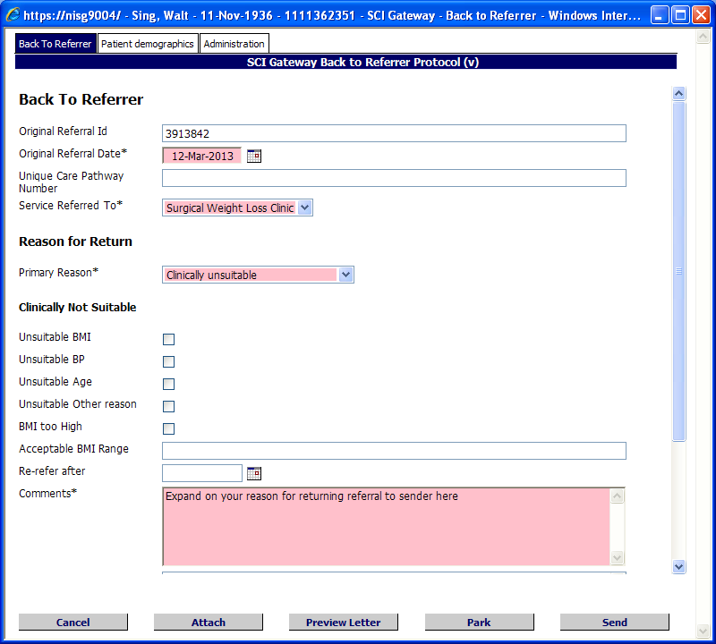
Details of the original referral here

Service referred to
Select reason for return to referrer here

Tick options that are relevant here

Enter full explanation here

Click here to cancel
Click to add an attachment
Click to preview the letter
Click to close and save for later
Click here to send

Ensure you complete all mandatory fields for example, sending healthcare professional or consultant details before clicking on Send.
Pictured below is the Back to Referrer Options window displayed after clicking on Send as described on the previous page:

Click on Proceed to continue

Click on OK to continue
Click on Cancel to go back

You are returned to worklist and the message you have just sent is displayed at the top of the list:

Back to referrer messages are displayed in the worklist with a blue curved arrow icon.

To find the patient referral to be returned to the referrer you can search on one patient identifier or a combination of indentifying criteria:

- Patient CHI – can be used to search without any other criteria
- Patient UCPN – can be used to search without any other criteria
- Forename – must be used in conjunction with Surname
- Surname – must be used in conjunction with Forename
- Date of Birth – can only be used in conjunction with other criteria e.g. UCPN

Receiving a Back to Referrer Message
If you have a referral returned to you from a receiving clinician you will receive it as a new incoming message in the same way as you would receive and eGPFR Request or a Discharge. From the home screen after logging on to SCI Gateway click on the link ‘You have x new Back to referrer’:

Click on the link to open the Back to referrer message

Select the tick boxes and click on Print to print the messages or click on Save to Docman to save a copy of the messages
Click on the patient name to open and view the message

Individual messages can also be saved to Docman by clicking on the context menu and selecting ‘Save to Docman’ as shown below:

Click on Save to Docman

Back to Referrer messages will not immediately be available when SCI Gateway is upgraded to v17.0. For more information on back to referrer messages see you local health board system administrator.

Advice Response Sending HCP Pre-population
Clinicians sending Advice Responses will now be able to select their name and details from a drop down list rather than having to manually enter all their details to the protocol. To create an Advice Response you must reply to an Advice Request.

Click on your new Advice Requests or alternatively point to Messages and select Advice Request if the message has previously been viewed
Click on the patient’s name to open the message

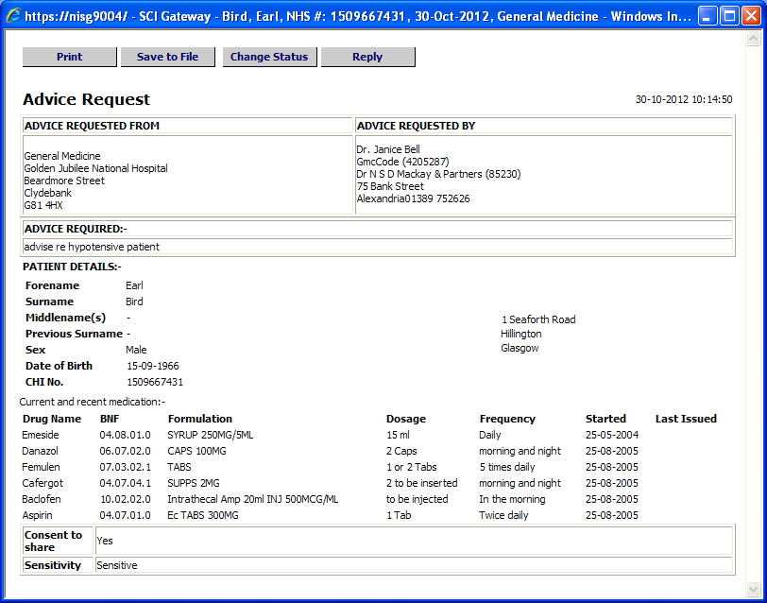
Click on Reply to create an Advice Response
Pictured below is the Advice Response protocol displayed after clicking on Reply as described on the previous page and with the Administration tab selected:

Select Specialty and HCP from drop down lists

Click here to close and complete at a later time
Click here to see a preview of the message
Click here to add an attachment
Click here to cancel the Advice Response
Click here to send the message

Ensure all mandatory fields are complete prior to sending. If you try to send without completing all mandatory fields a message will be displayed with a link to the missing information. Click on the link to go to the mandatory field, complete as required and click on Send.

Sending Messages from Secondary Care IT Systems
Non GP users of SCI Gateway can now send messages from their third party IT systems. All their patients demographics and relevant medical data will be pulled from the system and pre-populate the protocol thereby eliminating the need for lots of manual data entry.

Select your patient and log on to SCI Gateway from your IT system. The SCI Gateway Home page is displayed with the patient context set:

Point to New Message and select Referral
Pre-selected patient

Select destination options for the message

Select the required protocol
Click on Create
- Logging on to SCI Gateway through third party IT systems will vary depending on the system that you use. Please consult your local system administrator for more information on accessing SCI Gateway.
Pictured below is the unique care pathway option of the referral window, displayed after clicking on Create as described on the previous page. Patient referrals that have to comply with 18 week referral to treatment standard need to have a unique care pathway number so that the patient’s referral can be tracked. Select the required option below:

Select option as required
Click on Proceed

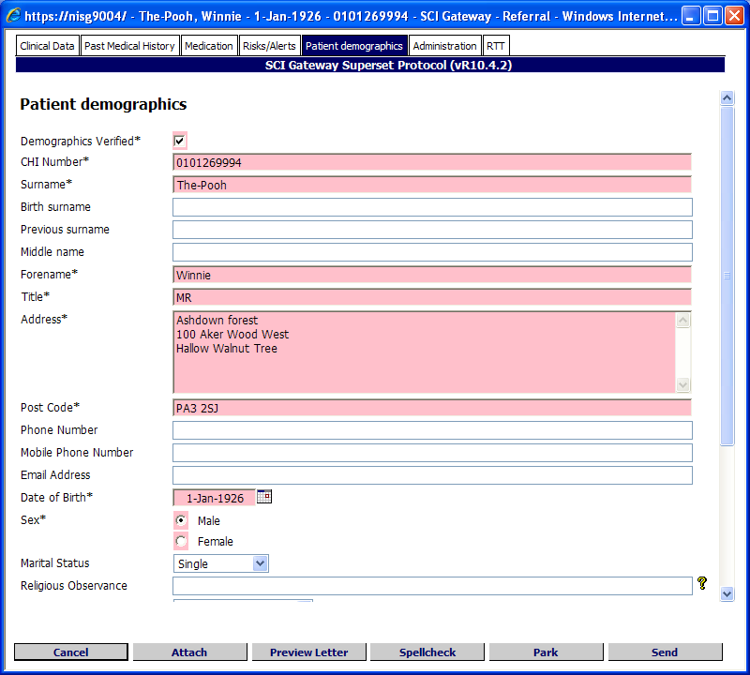
Click on Send

Protocols always open with the first tab at the top displayed. To add / view information click on each tab in turn. In the example above the Patient demographics tab has been selected and you can see the patient’s demographics which has been pulled from the third party IT system into the protocol. Once you have added all necessary information, click on the Send button.

Your protocol may look different from the one displayed above. Health boards are responsible for developing their own protocols and the protocol is owned by the receiving health board. Therefore protocols will vary depending where you are sending your message.
Pictured below is the Referral Options window displayed after clicking on Send as described on the previous page:

Click on Proceed to continue

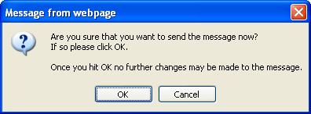
Click on OK to complete
Click on Cancel to go back and amend the protocol

Referral displayed in the Worklist

After clicking on OK as described above you are returned to the Referral Worklist and the message you have just sent is displayed. The message is ‘Read only’ and no changes can be made.

For more information on all message options and managing the worklist see the SCI Gateway
End User Guide: http://www.sci.scot.nhs.uk/products/gateway/user_guides.htm

To be able to use your IT systems to send messages through SCI Gateway your IT systems will need to be configured by their system administrators.

Static Horizontal Scroll Bar on Protocol Forms
There is new horizontal scroll bar which will automatically be displayed at the bottom of the protocol where the pre-populated patient information exceeds the length of the table in which it is displayed. Previously, the horizontal scroll bar would be displayed under the table to which it related. However, if there were numerous lines in the table the horizontal scroll would not be visible until the user had scrolled vertically down the screen.

Pictured below is an example of a protocol where two of the tables contain information too long for the table in which they are contained. The scroll bar is automatically displayed at the bottom of the screen and not under the table:

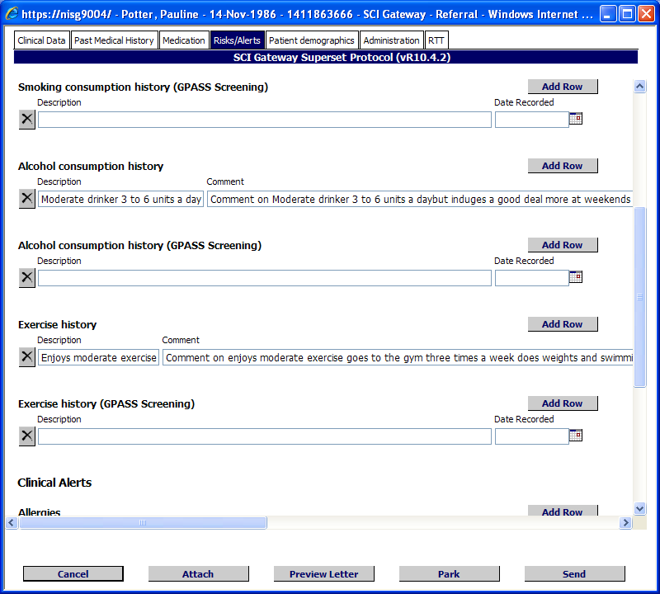
Horizontal scroll bar displayed
Tables with extra long patient information requiring user to scroll

GP Selected in Primary Care System pre-populates Protocol
Previously, when using some third party GP practice IT systems to connect to SCI Gateway, the selected GP did not transfer to the protocol sending the message. This resulted in the users having to select the sending GP twice, once in the third party GP IT system and once in the message protocol.

There has been a change made to SCI Gateway and users will now be able to select the GP in their GP IT system and it will be pre-populated in the protocol.

This option requires a change to be made in your local health board protocols. Please consult your system administrator in the first instance if you still have to select the GP in both your primary care IT system and the protocol.

This issue only relates to users of INPS Vision GP IT systems.

Known Issues and Fixes

CHI Matching – Names with Hyphens and Middle names
In version 16 of SCI Gateway CHI Matching option was introduced for healthcare professionals who do not usually use CHI as an identifier for their patients. After release it was discovered that patients with a hyphen in their names were failing the matching process. This has now been resolved and users will be able to match patients with a hyphen in their name.

Password errors
Previously, if users used special characters in their passwords on their GP IT systems, they would receive error messages when logging on to SCI Gateway. This has now been fixed and you can now use these characters. However, to do this you will need to install a new SCI Gateway client.

& | < | > | | | ~ | ¬ | ‘

Contact your local health board system administrator for more information on how to install a SCI Gateway client.

System Administrator Changes

Interactive Protocols
There are new questions available in protocols that when answered in the appropriate way will display / activate further questions and allow the sender to expand on the information requested. A new format of protocol XML has been created that will allow protocol writers to define the validation and interactivity rules that they require. It is not possible to update existing protocols with the new format for interactive protocols.

A change has been made to SCI Gateway so that it can manage the original and the new format therefore, there is no need to change your existing protocols. The two different protocol XML formats will be converted into an internal format which SCI Gateway will then use. To ensure performance is not impacted the protocol XML will be converted to the internal format when it is uploaded rather than on demand when a protocol web form is required. This means that both the original and the new formats will be stored in the SCI Gateway database.

A sample protocol will be delivered as part of the build and protocol writers can use that as a basis for developing there own interactive protocols. The protocol definition guide and the protocol verification tool have been updated to include the new elements required for interactive protocols.

Stylesheet
A new stylesheet has been created so that it can display both the original and the new format protocols. It will convert the original format protocols into the internal format protocol XML. It will determine whether the protocol XML is the original or the new format and display the appropriate web form.

Schemas
Schemas will be created for the original, new and internal format protocol XML. The new format schema will tightly control the allowed attributes and elements.

The original and internal format schemas will not be as tight as the format allows for ambiguities but will never the less improve the validation of the protocol XML when uploading it to SCI Gateway.

The new format schema will be used within the Protocol Verification Tool in order to validate and verify the protocol.

See the Protocol Verification Tool and the Protocol Definitions Guide for more information on writing new format protocols. If you require any more information on new format protocols contact NISG Support.

Clinical Dialogue Message

Adding Clinical Dialogue Message Capabilities to HCEs
HCEs will need to have the necessary capabilities if the users associated with them are to be able send and receive clinical dialogue messages. Navigate to the required location in the NHS Directory:

Select Capability from drop down list
Select Message Type from drop down list
Click on Add Capability

Each HCE that needs the capabilities for clinical dialogue messages must have the same action carried out as shown above for both sending and receiving capabilities i.e. Accept Clinical Dialogue and Make Clinical Dialogue.

Roles
New Roles will have to be created or existing roles amended to incorporate sending and receiving options for clinical dialogue messages. Users will need to have these roles assigned to them in order to be able to send and receive this message type. To create a new role point to Admin and select Roles from the Menu bar:

Point to Admin and select Roles

Click here to add a new role

Pictured below is the New Role Details window displayed after clicking on New Role as described on the previous page:

1 Enter Name

2 Select an Owner

3 Select receive or Send tab as required

4 Select options required
5 Highlight users to be added to the Role
6 Click here to add users to the Role
7 Click on Save

Confirmation message displayed

If all other configuration is complete end users assigned to the role will now be able to send clinical dialogue messages.

Clinical Dialogue Protocols & Stylesheets
New protocols and stylesheets will have to be published on SCI Gateway before users will be able to use clinical dialogue messages. Copies of the protocols and stylesheets will be available from NISG Support. Each health board can edit the originals or create their own to meet local requirements.

Protocols
To publish your own protocols open the Protocol window from the Menu Bar:

Point to Admin and select Protocols

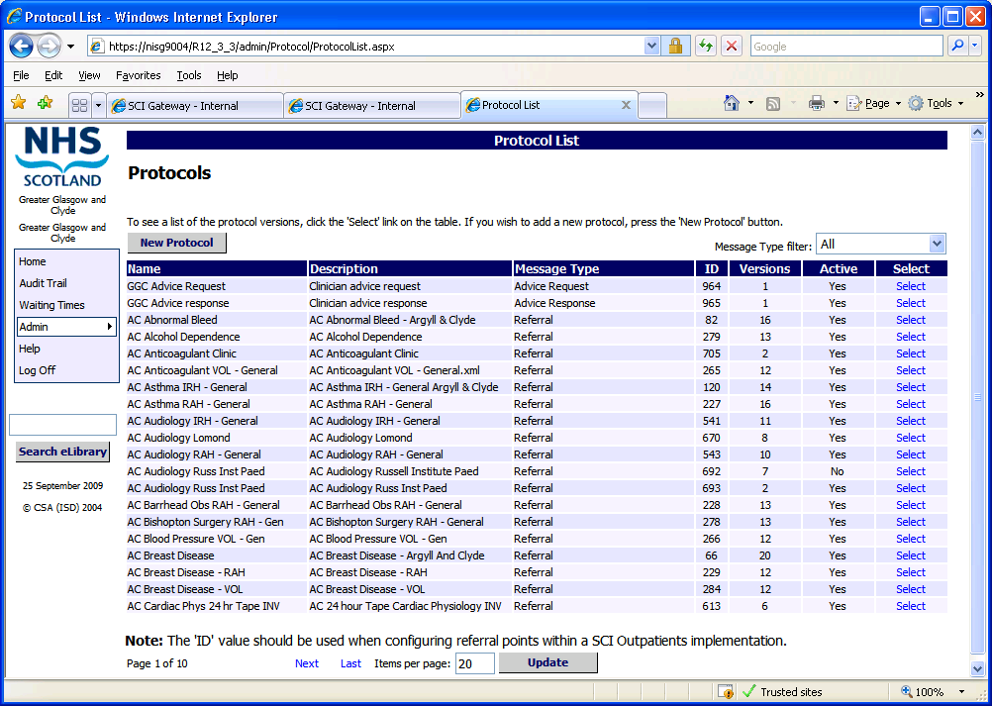
Click on New Protocol

Pictured below is the Add Protocol window which is displayed after clicking New Protocol as described on the previous page:

1 Enter Name

2 Enter Description

3 Select Message Type from drop down list
4 Select Owner from NHS Directory

5 Add HCEs required
7 Click here to activate
8 Click on Save
6 Click here to copy and paste XML

- Clinical dialogue protocols should be associated with any HCE in the NHS Directory that will receive these message types.
See the SCI Gateway Admin Guide for more information about adding protocols.

Stylesheets
To publish your new stylesheets open the Stylesheets window from the Menu Bar:

Point to Admin and select Stylesheets

Click on New Stylesheet

Pictured below is the Add Stylesheet window displayed after clicking on New Stylesheet as described on the previous page:

1 Enter Name

2 Enter Description

3 Select Message Type from drop down list
4 Select Owner from NHS Directory

5 Add HCEs required
9 Click on Save
8 Click here to activate

7 Enter GUID here or click on Generate to automatically enter a GUID
6 Click here to Add Stylesheet XSLT by copying from other source pasting here

- Clinical dialogue stylesheets should be associated with any HCE in the NHS Directory that will send these message types.
See the SCI Gateway Admin Guide for more information about adding stylesheets.

Back to Referrer Message
This is a new message type which will allow a clinician to respond to a referrer with feedback when the patient is being returned to referrer.

Adding Back to Referrer Message Capabilities to HCEs
HCEs will need to have the necessary capabilities if the users associated with them are to be able send and receive back to referrer messages. Navigate to the required location in the NHS Directory:

Select Capability from drop down list
Select Message Type from drop down list
Click on Add Capability

In the example above “Accept Back to Referrer” capability has been added to a GP practice. If the GP receives referrals they would also need to have “Make Back to Referrer” capability.

When you add this message type to HCEs in your health board “Accept Back to Referrer” capability should be added to any HCE that sends referrals and Make “Back to Referrer” capability to should be added to any HCE that receives referrals.

Roles
New Roles will have to be created or existing roles amended to incorporate sending and receiving options for back to referrer messages. Users will need to have these roles assigned to them in order to be able to send and receive this message type. To create a new role point to Admin and select Roles from the Menu bar:

Point to Admin and select Roles

Click here to add a new role

Pictured below is the New Role Details window displayed after clicking on New Role as described on the previous page:

1 Enter Name

2 Select an Owner

3 Select Receive or Send tab as required

4 Select options required
5 Highlight users to be added to the Role
6 Click here to add users to the Role
7 Click on Save

Confirmation message displayed

In the example pictured above a role has been created for accepting back to referrer messages. A role will also need to be created for users who need to be able to make back to referrer messages. Administrators will also need to configure a protocol, stylesheets and schemas before users will be able to send and receive back to referrer messages. See next page.

Back to Referrer Protocol & Stylesheet
A new protocol and stylesheet will have to be published on SCI Gateway before users will be able to use the back to referrer message. Copies of the protocol and stylesheet will be available from NISG Support. Each health board can edit the originals or create their own to meet local requirements.

Protocol
To publish your own protocol, open the Protocol window from the Menu Bar:

Point to Admin and select Protocols

Click on New Protocol

Pictured below is the Add Protocol window which is displayed after clicking New Protocol as described on the previous page:

1 Enter Name

2 Enter Description

3 Select Message Type from drop down list
4 Select Owner from NHS Directory

5 Add HCEs required
7 Click here to activate
6 Click on Save
6 Click here to copy and paste XML

- The back to referrer protocol should be associated with any HCE in the NHS Directory that will send this message type.
See the SCI Gateway Admin Guide for more information about adding protocols.

Stylesheets
To publish your new stylesheet open the Stylesheets window from the Menu Bar:

Point to Admin and select Stylesheets

Click on New Stylesheet

Pictured below is the Add Stylesheet window displayed after clicking on New Stylesheet as described on the previous page:

1 Enter Name

2 Enter Description

3 Select Message Type from drop down list
4 Select Owner from NHS Directory

5 Add HCEs required

6 Click here to activate
9 Click on Save

8 Enter GUID here or click on Generate to automatically enter a GUID
7 Click here to Add Stylesheet XSLT by copying from other source pasting here

- The back to referrer stylesheet should be associated with any HCE in the NHS Directory that will send this message type.
See the SCI Gateway Admin Guide for more information about adding stylesheets.

Show Coverage of HCE and Users
Previously it was not easy for an administrator to see who had access to messages sent and received by any specific location / HCE. A new option has been added to the NHS Directory which will make this information much more accessible.

To see a list of users who have coverage for a specific HCE navigate to the required HCE in the NHS Directory, in this example Beatson West of Scotland Oncology Centre has been used. This location does not have users registered at the HCE level in the NHS Directory.
No users for this HCE
Click on Coverage Users

A location does not need to have users registered at its HCE level in order for users to be able to see its received and sent messages.
Pictured below is the Coverage Users window displayed after clicking on the Coverage Users button as described on the previous page:

Users who can see the HCEs received messages.
Receiving Group(s) that cover the HCE.
Click here to return to the NHS directory.

Users who can see the HCEs sent messages.
Sending Group(s) that cover the HCE.
Click on [Permissions] to see the user’s permissions for each message type

Pictured below is a User Permission window displayed after clicking on the Permissions link as described on the previous page:

- When you click on the [Permissions] link in the Receiving Group Users section the users’ permissions for receiving messages for all message types will be displayed.

- When you click on the [Permissions] link in the Sending Group Users section the users’ permissions for sending messages for all message types will be displayed.

Sending Messages from IT Secondary Care systems
Third Party IT systems can now send message e.g. referrals and advice requests, in the same way as GP systems. The message protocol will be able to pull patients’ demographics, medical history and the referring HCEs’ details in to the protocol.

Users will be able to log on to SCI Gateway through their third party IT system either with a SCI Gateway user name and password or if currently used a single sign on system.

SCI Gateway will use the current official 18 Weeks RTT dataset and this will be included in the patient data XML.

The same unique care pathway (UCPN) rules will apply i.e. if the referral is part of a current pathway the UCPN will be carried forward if there is none SCI Gateway will generate a new UCPN.

To ensure that patient data from your IT system is valid, a new schema is needed. The new schema will be a copy of the current Third-Party-Interface-1.8.xsd, named PMS-Interface-v1.0.xsd. It will be given a new name PMS-Interface-v1.0.xsd to ensure a distinction is made between third party and PMS interfaces.

You will also be able to save a copy of the message to the third party IT system. However, to do this you will need to ensure that the usual configuration is completed on SCI Gateway for a sending HCE. The HCE will need to have the usual capabilities assigned and be active within the NHS Directory. Users will need to have group coverage and the necessary roles assigned.

A destination URL will need to be added for the third party system. Navigate to Destination URLs:

Point to Admin and select Destination URLs

Pictured below is the New URL Details window displayed after clicking on Destination URLs as described on the previous page:

Enter a name for the URL

Enter the URL here

Select an Owner from NHS Directory
Select Asynchronous – third party IT systems must be Asynchronous

Select Recipient Web Service v3.0

Select message type capabilities e.g Accept Referral
Select HCE(s) to be linked to the URL
Enter an email address of administrator responsible for monitoring Dead Messages and click on Add to List
Click on Save

Once you have clicked on Save as described on the previous page and all other configuration has been completed the HCE will be able to send messages with pre-population of patient and HCE details and save a copy of the message to your system.

You can assign one or multiple message type capabilities to the URL. For example if the HCE sends and receives referrals you would select make referral and accept referral to the destination URL.

Please see the Developer kit for all other information on changes to your third party IT systems and for the new schema.

Changes to Protocol XML and Stylesheet XSLT
In order to be able to pre-populate the protocol with the referring clinician’s details you will need to add a new element to your protocol XML and stylesheet XSLT, see below for examples:

Start of Hospital Details
<question text="HCP Registration Scheme" type="hidden" id="refhcp_scheme" object="ReferringHcp" property="HcpCodeScheme" />
<question text="HCP GMC Code" type="text" id="refhcp_gmc_code" mandatory="true" object="ReferringHcp" property="HcpCode" />
<question text="HCP Forename" type="text" id="refhcp_forename" mandatory="true" object="ReferringHcp" property="Forename" />
<question text="HCP Surname" type="text" id="refhcp_surname" mandatory="true" object="ReferringHcp" property="Surname" />
<question text="HCP Position" type="text" id="refhcp_position" object="ReferringHcp" property="Position" />
<question text="Referring Specialty Name" type="text" id="refhcp_specialty_name" object="ReferringHcp" property="SpecialtyName" />
<question text="Referring Speiclaty Code" type="text" id="refhcp_specialty_code" object="ReferringHcp" property="SpecialtyCode" />
<question text="Org Name" type="text" id="reforg_name" mandatory="true" object="ReferringClinicianOrg" property="Name" />
<question text="Org Location Code" type="text" id="reforg_location_code" mandatory="true" object="ReferringClinicianOrg" property="LocationCode" />
<question text="Org Address" type="textArea" id="reforg_address" mandatory="true" object="ReferringClinicianOrg" property="Address" />
<question text="Org Postcode" type="text" id="reforg_postcode" mandatory="true" object="ReferringClinicianOrg" property="Postcode" />
<question text="Org Phone" type="text" id="reforg_phone" object="ReferringClinicianOrg" property="Telephone" />
- <!--
End of Hospital Details
Stylesheet

<xsl:template match="ref:ReferringParty">
<xsl:param name="forename" select="gen:HcpName/gen:StructuredName/gen:GivenName" />
<xsl:param name="surname" select="gen:HcpName/gen:StructuredName/gen:FamilyName" />
- <xsl:param name="formattedname">
<xsl:value-of select="$forename" />
<xsl:text />
<xsl:value-of select="$surname" />
</xsl:param>
- <table border="0">
<xsl:value-of select="$formattedname" />
<br />
<xsl:value-of select="gen:HcpSpecialty/gen:SpecialtyName" />
<br />
<xsl:value-of select="gen:EmployingOrganisation/gen:OrganisationName" />
<br />
- <xsl:for-each select="gen:EmployingOrganisation/gen:OrganisationAddress/gen:StructuredAddress/gen:AddressLine">
<xsl:value-of select="." />
<br />
</xsl:for-each>
</table>
</xsl:template>

Advice Response Pre-population of HCP
Clinicians sending Advice Responses will now be able to select their name and details from a drop down list rather than having to key in all the details to the protocol. In order for this to happen a change needs to be made to the protocol XML.

The protocol must include questions for both a requesting GP and a requesting HCP. SCI Gateway will determine which questions to display based on the destination of the reply message. This will require amendments to existing configuration files and internal stylesheets within SCI Gateway. Pictured below is an example of protocol XML including both GP and HCP questions:

<category text="Requested By">
Requesting GP
<question text="Name" type="text" id="requestinggp_name" object="AdviceRequest" property="GpName" />
<question text="GMC Code" type="text" id="requestinggp_gmc_code" object="AdviceRequest" property="GpGmcCode" />
<question text="GP Code" type="text" id="requestinggp_code" object="AdviceRequest" property="GpCode" />
<question text="Practice Code" type="text" id="requestinggp_practice_code" object="AdviceRequest" property="PracticeCode" />
<question text="Practice Name" type="text" id="requestinggp_practice_name" object="AdviceRequest" property="PracticeName" />
<question text="Address" type="textArea" id="requestinggp_practice_address" object="AdviceRequest" property="PracticeAddress" />
<question text="Phone Number" type="text" id="requestinggp_practice_phone" object="AdviceRequest" property="PracticePhoneNo" />
<question text="Fax Number" type="text" id="requestinggp_practice_fax" object="AdviceRequest" property="PracticeFaxNo" />
End
Requesting HCP
<question text="Forename" type="text" id="requestinghcp_forename" object="AdviceRequest" property="ReqByHcpForename" />
<question text="Surname" type="text" id="requestinghcp_surname" object="AdviceRequest" property="ReqByHcpSurname" />
<question text="GMC Code" type="text" id="requestinghcp_gmc_code" object="AdviceRequest" property="ReqByHcpCode" />
<question text="Hospital Name" type="text" id="requestingorg_name" object="AdviceRequest" property="ReqByOrgName" />
<question text="Hospital Address" type="textArea" id="requestingorg_address" object="AdviceRequest" property="ReqByOrgAddress" />
- <!--
End
</category>

Pictured below is the Styleshteet XSLT required to display the HCP sender of the Advice Response:

<xsl:template match="adRes:AdviceSentBy">
<xsl:param name="forename" select="gen:HcpName/gen:StructuredName/gen:GivenName" />
<xsl:param name="surname" select="gen:HcpName/gen:StructuredName/gen:FamilyName" />
- <xsl:param name="formattedname">
<xsl:value-of select="$forename" />
<xsl:text />
<xsl:value-of select="$surname" />
</xsl:param>
- <table border="0">
<xsl:value-of select="$formattedname" />
<br />
<xsl:value-of select="gen:HcpSpecialty/gen:SpecialtyName" />
<br />
<xsl:value-of select="gen:EmployingOrganisation/gen:OrganisationName" />
<br />
- <xsl:for-each select="gen:EmployingOrganisation/gen:OrganisationAddress/gen:StructuredAddress/gen:AddressLine">
<xsl:value-of select="." />
<br />
</xsl:for-each>
</table>
</xsl:template>

The HCP details will only be displayed when SCI Gateway determines that the Advice Response is coming from a Non- GP Location and that the sender is an HCP rather than a GP.

Destination URLs – Modify Capability
In version 16 of SCI Gateway Destination URLs was removed from local health board administrators so that NISG could control the security of systems that link to SCI Gateway. This left administrators unable to attach or detach HCEs from URLs. A new capability called Destination URLS - Modify has been added which will resume that level of control for administrators.

In the first instance NISG Support will assign the new capability to designated health board administrators. Thereafter, administrators can assign the capability to others in their own health board where required.

Navigate to the user who requires the capability:

Click on [Maintain]

Select Destination URLs Attach/Detach from the drop down list
Click on Add
Click on Save

Once saved administrators will be able to attach and detach HCEs to destination URLs.

Attaching and Detaching HCEs
On occasion you may have a need to attach or detach an HCE to a destination URL. Point to Admin and select Destination URLS – Modify:

Point to Admin and select Destination URLs

Click on [Update] for the URL that you want to modify

Name, URL Send Method and Interface all Read Only
Click on HCEs to attach or detach

Pictured below is the NHS Directory window displayed after clicking on the HCE button as described on the previous page:

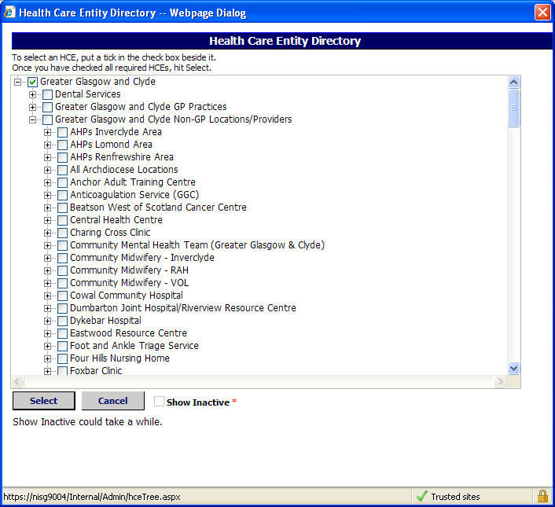
Tick or untick beside HCEs as required
Click on Select to confirm and return to the Edit URL details window

Place a tick beside an HCE to attach to the URL or click on a tick beside and HCE to detach from the URL.

Click on the plus sign to expand the list or the minus sign to close the list.

Pictured below is the Edit URL Details window displayed after clicking on Select as described on the previous page:

Edit messages types as required – attach message types by ticking the box or detach message types by removing the tick
Edit dead message number, Status and / or Priority as required
Click on Save to save all changes

Administrators with Destination URLs – Modify capability cannot add new Destination URLs or edit the Name, URL, Interface or Send Method of an existing Destination URL. If you need to edit any of these options or add a new Destination URL contact the your local health board administrator who has Destination URLs capability or NISG Support.

Destination URL - Owner
When SCI Gateway R17 is upgraded Destination URLs will automatically be assigned an Owner in the same way as protocols and stylesheets have owners.

The owner assigned will be determined by the user who added the destination URL to SCI Gateway. For example, if the destination URL was added by NISG Support the Owner will be NHS Scotland. If the destination URL was added by an administrator at a local health board the Owner will be the name of the health board e.g. Greater Glasgow and Clyde.

To add an Owner to a destination URL open Destination URLs from the Admin menu:

Point to Admin and select Destination URLs

Click on New URL

Pictured below is the New URLs Details window displayed after clicking on the New URLs button as described on the previous page:

Enter a name for the URL

Enter the URL here

Click on Owner button

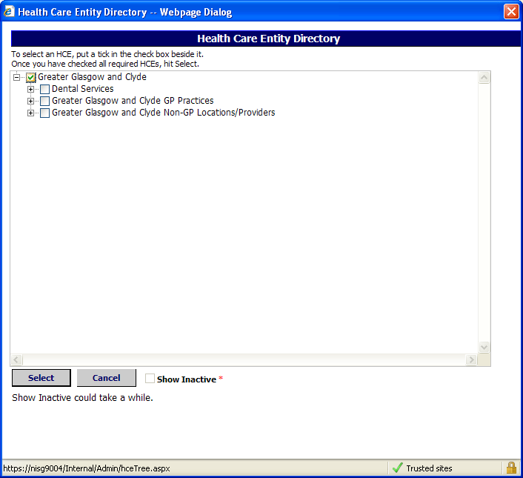
Place a tick next to the required HCE
Click on Select

The Owner HCE must be the set at the lowest level of users who will mange the URL; i.e. If you have an administrator with user details set at Non-GP Locations/Providers, who will attach and detach HCEs from destination URLs, the destination URL Owner must be set at Non-GP Locations level. If it is set at health board level the administrator set at Non GP Locations level will not be able to see the destination URL.
Pictured below is the New URLs Details window displayed after clicking on the Select button as described on the previous page:

Owner displayed here
Select required message types
Click on Save

Message displayed confirming successful creation of destination URL

National Optometry Branch
The national Optometry branch has been added to the NHS Directory through the ISD reference files. In order for opticians to send messages through SCI Gateway their HCEs will need to be configured in the same way as any other HCE.

Users will have to be added with the appropriate roles and groups assigned. The HCE will need to be activated, have capabilities for the relevant message type and any appropriate extras and destination URLs configured e.g. CHI matching / look up.

Click on the branch to expand, and activate and configure as required

Hover the mouse over the location name to see the first line of the address

The process for adding Optometrist to the NHS Directory will be dealt with in a similar way to GPs i.e. individual Optometrists need to be registered with their local health board before they can be included in the NHS Directory. Once they are included they need to be activated and assigned usernames in the same way as you would a GP.

If you require any assistance in activating and configuring the Optometry branch contact NISG Support.

- The Optometry branch will not go Live immediately on upgrade to V17.0. You will be notified prior to it being included in the ISD update.
Maintain Sender option should not be used to add an optometrist or edit the details of an Optometry practice now that the practices are a core branch of the NHS directory. These actions would result in overwriting all the practice details.

Consistent Status Ids
The different instances of SCI Gateway, Live, Training, UAT etc use different databases and currently the different databases use different status IDs to identify a status being set on a message that is sent through SCI Gateway. Health boards have had to find ways of storing status IDs for each of the instances in order to manage the inconsistencies.

A new method of setting messages statuses has been introduced to enable Status ID setting in a consistent manner across SCI Gateway instances.

Instead of a Status ID the message status will be passed as text. To ensure the message status is set correctly a new web method has been developed which will accept the message status text as a parameter. The server will look for an exact match of the text and set the status.

Third Party Systems will need to be updated to call the new web method to utilise the new functionality. However, health boards can continue to use their current configuration files for status IDs until they update their third party systems.

SCI Gateway Service_3_0 has been updated to accept the message status text.

For more information on Consistent Status IDs please see the R6.0 Developer Kit

GP selected in Primary Care System pre-populates Protocol
Previously when using some third party GP practice IT systems to connect to SCI Gateway, the selected GP did not transfer to the protocol sending the message. This resulted in the users having to select the sending GP twice, once in the third party GP IT system and once in the message Protocol.

There has been a change made to SCI Gateway and users will now be able to select the GP in their GP IT system and it will be pre-populated in the protocol.

Protocol Configuration
This change requires a change to the protocol XML. Within the protocol XML, the <control> tag for the referrer/registrar control will be able to have a new, optional, attribute of “autoselect” with an expected value of “true”. If the attribute value is “true”, the auto-selection functionality will be considered to be “switched on” for the control. If the attribute is either not present or does not have the value “true” then auto-selection will not take place, i.e. it is switched off.

The attribute value will not be case sensitive, i.e. if it is “True” or “TRUE” then auto-selection will be switched on.

A check will be made in ViewMessage.aspx.cs for whether the referrer control and/or registrar control, if they exist in the protocol XML, are configured to have auto-selection switched on.

Auto-selection pre-requisites
In addition to a change in protocol XML, the auto-selection of the referring/registered GP will only take place if the following are true:

- The application is running in patient context
- The protocol has the referrer and/or registrar control
- Auto-selection is configured for the control in the protocol
- The GP GMC code has been retrieved from the patient details XML
- The logged-on user’s home HCE is in the old part of the HCE tree within the GP Practices branch
- The GP has not already been selected (this happens when the user’s home HCE is the GP HCE rather than the GP practice HCE)

This issue only relates to users of INPS Vision GP IT systems.

Read Codes in XML
Previously when Read codes were pulled from a patient’s record to pre-populate a protocol the actual code XML was discarded and the name of the patient’s condition / procedure was saved and displayed in the protocol and final letter.

There has been a change made to SCI Gateway and it is now possible for third party systems to retain the Read code if they choose to. However you will need to make changes to protocols if Read code XML is to be retained. The details can be found in the Protocol Definition guide and Protocol Changes guide.

The Protocol Verification Tool has also been updated for this version of SCI Gateway. Contact NISG Support for more information on the new Protocol Verification Tool.

Third party systems will have to be updated in order to store Read code XML. However, there is no need to make an immediate change as SCI Gateway will continue function in the same way as previous. See the Developer Kit for more information if you would like to store READ code XML in your third party system.

